**Roll No.**

|  |  |  |  |  |  |
| --- | --- | --- | --- | --- | --- |
| **MCALE323 Distributed System and Cloud Computing Lab**  **Index** | | | | | |
| **Sr.**  **No.** | **Topic Name** | **Date** | **CO** | | **Sign** |
| **1.** | **Remote Process Communication:**   1. To develop a program for multi-client chat server using Socket 2. To implement a Server calculator using RPC concept. (Make use of datagram) 3. To implement a Date Time Server using RPC concept. (Make use of datagram) 4. To implement a Server calculator using RPC concept. (Make use of Server Socket) 5. To implement a Date Time Server using RPC concept. (Make use of Server Socket) |  | **CO1** | |  |
| **2.** | **Remote Procedure Call:**   1. Implement a Server calculator containing ADD (), MUL (), SUB () etc. 2. Implement a Date Time Server containing date() and time() 3. Implement a Server to do the following    1. User will enter two values in hours and minutes from the client (Eg: 3 hour 40 minutes and 2 hour 50 minutes)    2. Server will add hour and minute components separately. The client side receives the result and displays the value       1. only in hours (Eg: 06:30 Hours)       2. only in minutes (Eg:390 Minutes) 4. Implement a Server to do the following    1. Get a string from the client.    2. Find the reverse of the string at the server side    3. The client side receives the reversed string and verifying whether it is palindrome 5. Implement a Server to do the following    1. Get one number from the client.    2. Server will find whether the number from client is odd or even    3. After receiving the result from server client displays the message    4. If the number is even client will calculate the table of the number |  | **CO1 CO2** | |  |
| **3.** | **Remote Method Invocation**   1. Calculate addition of two numbers and send it to the client using **RMI**. 2. Retrieve time and date function from server to client. This program should display server date and time by implementing **RMI**   **Equation Solver:**   1. The client should provide the values of a and b. The server will solve the equation (a+b)2=a2+2ab+b2 and will give back the value of equation using **RMI**. 2. The client should provide the values of a and b. The server will solve the equation (a+b)2=a2+2ab+b2 and (a-b)2=a2+2ab+b2 and will give back the value of equation (**Use RMI**) |  | **CO1 CO2** | |  |
| **4.** | **Remote Method Invocation (Graphical User Interface)**   1. Design a Graphical User Interface for addition of two numbers. Implement using RMI 2. Design a Graphical User Interface (GUI) to find factorial of a given number. Implement using RMI 3. Design a Graphical User Interface (GUI) based Basic calculator by implementing RMI 4. Design a Graphical User Interface (GUI) to find greatest of two numbers. Implement using RMI 5. Design a Graphical User Interface (GUI) which accepts a numerical value from the client. Convert the number in to words. Implement using RMI |  | **CO1 CO2** |  | |
| **5** | **Using MySQL create a Library database. Create table Book (Book_id, Book_name, Book_author) and retrieve the Book information from the library database using the Remote Object Communication concept.** |  | **CO2** |  | |
| **6** | **Using MySQL create a student database. Create table student_data(ID, NAME, BRANCH, PERCENTAGE, EMAIL) and retrieve the student_data information from Student database using Remote Object Communication concept.** |  | **CO2** |  | |
| **7** | **Using MySQL create ElecrticBill database. Create table**  **Bill (consumer_name, bill_due_date, bill_amount) and retrieve the Bill information from the ElecrticBill database using Remote Object**  **Communication concept.** |  | **CO2** |  | |
| **8** | **Implementation of mutual exclusion using Token ring algorithm** |  | **CO3** |  | |
| **9** | **Implementation of Election Algorithm using Ring Algorithm.** |  | **CO3** |  | |
| **10** | **Implementation of Storage as a Service**  Implementation of Storage as a Service (STaaS) using Amazon S3 (Simple Storage Service) |  | **CO4** |  | |
| **11** | **Implementation of Identity Management.**  Implementation of Identity and Access Management (IAM) in **AWS** |  | **CO5** |  | |
| **12** | **Create a virtual machine (VM) on any cloud provider (AWS/Azure/GCP) of your choice with the specifications:**   * Operating System, VM Type, Disk Size, Public IP, Network Rules * **Once created, verify that the VM is running and submit a screenshot of the instance details and a brief description of the steps you followed.** * Create a virtual machine (VM) on any cloud provider (AWS) |  | **CO6** |  | |
| **13** | Group projects (2 to 3 members) are to be given the opportunity to work on any Cloud Concept.   * Attach synopsis |  |  |  | |

# 1.Remote Process Communication:

## 1. To develop a program for multi-client chat server using Socket

### MultiClientChatServer.java:

import java.io.*;

import java.net.*;

import java.util.*;

public class MultiClientChatServer {

private static Set<ClientHandler> clientHandlers = new HashSet<>();

public static void main(String[] args) {

try {

ServerSocket serverSocket = new ServerSocket(5000);

System.out.println("Multi-client Chat Server started...");

while (true) {

Socket clientSocket = serverSocket.accept();

System.out.println("New client connected: " + clientSocket.getInetAddress().getHostAddress());

ClientHandler clientHandler = new ClientHandler(clientSocket);

clientHandlers.add(clientHandler);

new Thread(clientHandler).start();

}

} catch (IOException e) {

System.out.println("Server Error: " + e.getMessage());

}

}

static void broadcast(String message, ClientHandler sender) {

for (ClientHandler client : clientHandlers) {

if (client != sender) {

client.sendMessage(message);

}

}

}

static void removeClient(ClientHandler clientHandler) {

clientHandlers.remove(clientHandler);

}

}

class ClientHandler implements Runnable {

private Socket socket;

private BufferedReader input;

private PrintWriter output;

private String clientName;

public ClientHandler(Socket socket) {

this.socket = socket;

try {

input = new BufferedReader(new InputStreamReader(socket.getInputStream()));

output = new PrintWriter(socket.getOutputStream(), true);

output.println("Enter your name: ");

clientName = input.readLine();

broadcast(clientName + " has joined the chat!");

} catch (IOException e) {

System.out.println("I/O Error: " + e.getMessage());

}

}

@Override

public void run() {

String message;

try {

while ((message = input.readLine()) != null) {

if (message.equalsIgnoreCase("exit")) {

output.println("You left the chat.");

System.out.println(clientName + " disconnected.");

broadcast(clientName + " has left the chat.", this);

MultiClientChatServer.removeClient(this);

break;

}

String formattedMessage = clientName + ": " + message;

System.out.println(formattedMessage);

MultiClientChatServer.broadcast(formattedMessage, this);

}

input.close();

output.close();

socket.close();

} catch (IOException e) {

System.out.println("Client Error: " + e.getMessage());

}

}

void sendMessage(String message) {

output.println(message);

}

void broadcast(String message) {

MultiClientChatServer.broadcast(message, this);

}

}

### MultiClientChatClient.java:

import java.io.*;

import java.net.*;

import java.util.Scanner;

public class MultiClientChatClient {

public static void main(String[] args) {

try {

Socket socket = new Socket("localhost", 5000);

BufferedReader input = new BufferedReader(new InputStreamReader(socket.getInputStream()));

PrintWriter output = new PrintWriter(socket.getOutputStream(), true);

Scanner scanner = new Scanner(System.in);

new Thread(() -> {

String serverMessage;

try {

while ((serverMessage = input.readLine()) != null) {

System.out.println(serverMessage);

}

} catch (IOException e) {

System.out.println("Connection closed.");

}

}).start();

while (true) {

String message = scanner.nextLine();

output.println(message);

if (message.equalsIgnoreCase("exit")) {

break;

}

}

scanner.close();

input.close();

output.close();

socket.close();

} catch (IOException e) {

System.out.println("Client Error: " + e.getMessage());

}

}

}

### Output:

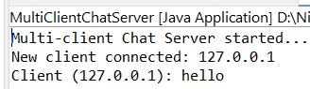

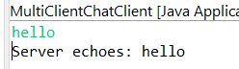

## 2. To implement a Server calculator using RPC concept. (Make use of datagram)

### CalculatorServer.java:

package socket_prac;

import java.net.*;

import java.io.*;

public class CalculatorServer {

public static void main(String[] args) {

try {

DatagramSocket serverSocket = new DatagramSocket(5000);

System.out.println("UDP Calculator Server started. Waiting for client requests...");

byte[] receiveBuffer = new byte[1024];

byte[] sendBuffer;

while (true) {

DatagramPacket receivePacket = new DatagramPacket(receiveBuffer, receiveBuffer.length);

serverSocket.receive(receivePacket);

String clientRequest = new String(receivePacket.getData(), 0, receivePacket.getLength());

System.out.println("Received from client: " + clientRequest);

if (clientRequest.equalsIgnoreCase("exit")) {

System.out.println("Client disconnected.");

break;

}

String[] parts = clientRequest.split(" ");

String response;

if (parts.length != 3) {

response = "Invalid format! Use: OPERATION num1 num2";

} else {

try {

String operation = parts[0].toUpperCase();

double num1 = Double.parseDouble(parts[1]);

double num2 = Double.parseDouble(parts[2]);

double result;

switch (operation) {

case "ADD":

result = num1 + num2;

response = "Result: " + result;

break;

case "SUB":

result = num1 - num2;

response = "Result: " + result;

break;

case "MUL":

result = num1 * num2;

response = "Result: " + result;

break;

case "DIV":

if (num2 == 0) {

response = "Error: Division by zero!";

} else {

result = num1 / num2;

response = "Result: " + result;

}

break;

default:

response = "Unknown operation. Use ADD, SUB, MUL, or DIV.";

break;

}

} catch (Exception e) {

response = "Error: Invalid numbers!";

}

}

InetAddress clientAddress = receivePacket.getAddress();

int clientPort = receivePacket.getPort();

sendBuffer = response.getBytes();

DatagramPacket sendPacket = new DatagramPacket(sendBuffer, sendBuffer.length, clientAddress, clientPort);

serverSocket.send(sendPacket);

}

serverSocket.close();

} catch (IOException e) {

System.out.println("Server Error: " + e.getMessage());

}

}

}

### CalculatorClient.java:

package socket_prac;

import java.net.*;

import java.io.*;

import java.util.Scanner;

public class CalculatorClient {

public static void main(String[] args) {

try {

DatagramSocket socket = new DatagramSocket();

InetAddress serverAddress = InetAddress.getByName("localhost");

Scanner scanner = new Scanner(System.in);

System.out.println("Connected to UDP Calculator Server.");

System.out.println("\nAvailable operations: ADD, SUB, MUL, DIV");

System.out.println("Format: OPERATION num1 num2 (e.g., ADD 5 10)");

System.out.println("Type 'exit' to quit.\n");

byte[] sendBuffer;

byte[] receiveBuffer = new byte[1024];

while (true) {

System.out.print("Enter command: ");

String userInput = scanner.nextLine();

sendBuffer = userInput.getBytes();

DatagramPacket sendPacket = new DatagramPacket(sendBuffer, sendBuffer.length, serverAddress, 5000);

socket.send(sendPacket);

if (userInput.equalsIgnoreCase("exit")) {

System.out.println("Closing connection...");

break;

}

DatagramPacket receivePacket = new DatagramPacket(receiveBuffer, receiveBuffer.length);

socket.receive(receivePacket);

String response = new String(receivePacket.getData(), 0, receivePacket.getLength());

System.out.println("Server: " + response);

}

scanner.close();

socket.close();

} catch (IOException e) {

System.out.println("Client Error: " + e.getMessage());

}

}

}

### Output:

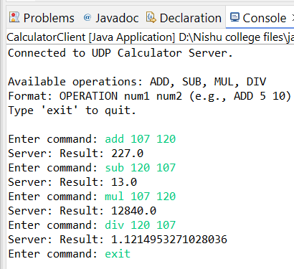

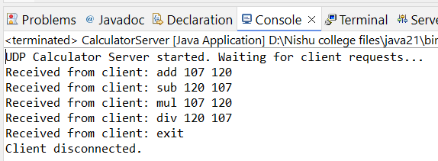

## 3. To implement a Date Time Server using RPC concept. (Make use of datagram)

### DateTimeServer.java:

package socket_prac;

import java.net.*;

import java.io.*;

import java.time.LocalDate;

import java.time.LocalTime;

import java.time.format.DateTimeFormatter;

public class DateTimeServer {

public static void main(String[] args) {

try {

DatagramSocket serverSocket = new DatagramSocket(5001);

System.out.println("UDP Date-Time Server started...");

System.out.println("Waiting for client requests...");

byte[] receiveBuffer = new byte[1024];

byte[] sendBuffer;

while (true) {

DatagramPacket receivePacket = new DatagramPacket(receiveBuffer, receiveBuffer.length);

serverSocket.receive(receivePacket);

String clientRequest = new String(receivePacket.getData(), 0, receivePacket.getLength());

System.out.println("Received from client: " + clientRequest);

if (clientRequest.equalsIgnoreCase("exit")) {

System.out.println("Client disconnected.");

break;

}

String response;

switch (clientRequest.toLowerCase()) {

case "date":

LocalDate date = LocalDate.now();

response = "Current Date: " + date.format(DateTimeFormatter.ofPattern("dd-MM-yyyy"));

break;

case "time":

LocalTime time = LocalTime.now();

response = "Current Time: " + time.format(DateTimeFormatter.ofPattern("HH:mm:ss"));

break;

default:

response = "Invalid command! Use 'date' or 'time'.";

break;

}

InetAddress clientAddress = receivePacket.getAddress();

int clientPort = receivePacket.getPort();

sendBuffer = response.getBytes();

DatagramPacket sendPacket = new DatagramPacket(sendBuffer, sendBuffer.length, clientAddress, clientPort);

serverSocket.send(sendPacket);

}

serverSocket.close();

} catch (IOException e) {

System.out.println("Server Error: " + e.getMessage());

}

}

}

### DateTimeClient.java:

package socket_prac;

import java.net.*;

import java.io.*;

import java.util.Scanner;

public class DateTimeClient {

public static void main(String[] args) {

try {

DatagramSocket socket = new DatagramSocket();

InetAddress serverAddress = InetAddress.getByName("localhost");

Scanner scanner = new Scanner(System.in);

System.out.println("Connected to UDP Date-Time Server.");

System.out.println("\nAvailable commands: 'date', 'time'");

System.out.println("Type 'exit' to quit.\n");

byte[] sendBuffer;

byte[] receiveBuffer = new byte[1024];

while (true) {

System.out.print("Enter command: ");

String userInput = scanner.nextLine();

sendBuffer = userInput.getBytes();

DatagramPacket sendPacket = new DatagramPacket(sendBuffer, sendBuffer.length, serverAddress, 5001);

socket.send(sendPacket);

if (userInput.equalsIgnoreCase("exit")) {

System.out.println("Closing connection...");

break;

}

DatagramPacket receivePacket = new DatagramPacket(receiveBuffer, receiveBuffer.length);

socket.receive(receivePacket);

String response = new String(receivePacket.getData(), 0, receivePacket.getLength());

System.out.println("Server: " + response);

}

scanner.close();

socket.close();

} catch (IOException e) {

System.out.println("Client Error: " + e.getMessage());

}

}

}

### Output:

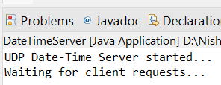

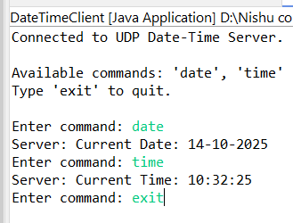

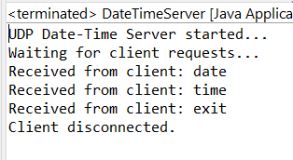

## 4. To implement a Server calculator using RPC concept. (Make use of Server Socket)

### CalculatorServer.java:

package socket_prac;

import java.io.*;

import java.net.*;

public class CalculatorServer {

public static void main(String[] args) {

try {

ServerSocket serverSocket = new ServerSocket(5000);

System.out.println("Server started. Waiting for client connection...");

Socket socket = serverSocket.accept();

System.out.println("Client connected!");

BufferedReader input = new BufferedReader(new InputStreamReader(socket.getInputStream()));

PrintWriter output = new PrintWriter(socket.getOutputStream(), true);

String clientRequest;

while ((clientRequest = input.readLine()) != null) {

if (clientRequest.equalsIgnoreCase("exit")) {

System.out.println("Client disconnected.");

break;

}

System.out.println("Received from client: " + clientRequest);

String[] parts = clientRequest.split(" ");

if (parts.length != 3) {

output.println("Invalid format! Use: OPERATION num1 num2");

continue;

}

String operation = parts[0].toUpperCase();

double num1 = Double.parseDouble(parts[1]);

double num2 = Double.parseDouble(parts[2]);

double result = 0.0;

switch (operation) {

case "ADD":

result = num1 + num2;

break;

case "SUB":

result = num1 - num2;

break;

case "MUL":

result = num1 * num2;

break;

case "DIV":

if (num2 == 0) {

output.println("Error: Division by zero!");

continue;

}

result = num1 / num2;

break;

default:

output.println("Unknown operation. Use ADD, SUB, MUL, or DIV.");

continue;

}

output.println("Result: " + result);

}

input.close();

output.close();

socket.close();

serverSocket.close();

} catch (IOException e) {

System.out.println("Server Error: " + e.getMessage());

}

}

}

### CalculatorClient.java:

package socket_prac;

import java.io.*;

import java.net.*;

import java.util.*;

public class CalculatorClient {

public static void main(String[] args) {

try {

Socket socket = new Socket("localhost", 5000);

System.out.println("Connected to Calculator Server.");

BufferedReader input = new BufferedReader(new InputStreamReader(socket.getInputStream()));

PrintWriter output = new PrintWriter(socket.getOutputStream(), true);

Scanner scanner = new Scanner(System.in);

System.out.println("\nAvailable operations: ADD, SUB, MUL, DIV");

System.out.println("Format: OPERATION num1 num2 (e.g., ADD 5 10)");

System.out.println("Type 'exit' to quit.\n");

String userInput;

while (true) {

System.out.print("Enter command: ");

userInput = scanner.nextLine();

output.println(userInput);

if (userInput.equalsIgnoreCase("exit")) {

System.out.println("Closing connection...");

break;

}

String response = input.readLine();

System.out.println("Server: " + response);

}

scanner.close();

input.close();

output.close();

socket.close();

} catch (IOException e) {

System.out.println("Client Error: " + e.getMessage());

}

}

}

### Output:

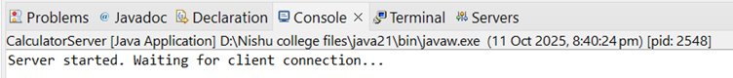

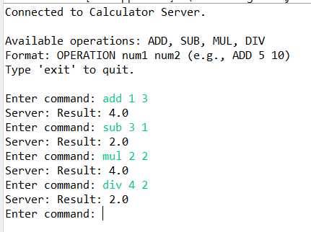

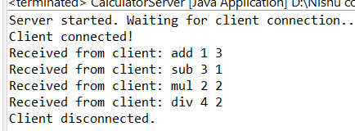

## 5. To implement a Date Time Server using RPC concept. (Make use of Server Socket)

### DateTimeServer.java:

package socket_prac;

import java.io.*;

import java.net.*;

import java.time.LocalDate;

import java.time.LocalTime;

import java.time.format.DateTimeFormatter;

public class DateTimeServer {

public static void main(String[] args) {

try {

ServerSocket serverSocket = new ServerSocket(5001);

System.out.println("Date-Time Server started...");

System.out.println("Waiting for client connection...");

Socket socket = serverSocket.accept();

System.out.println("Client connected!");

BufferedReader input = new BufferedReader(new InputStreamReader(socket.getInputStream()));

PrintWriter output = new PrintWriter(socket.getOutputStream(), true);

String clientRequest;

while ((clientRequest = input.readLine()) != null) {

System.out.println("Received from client: " + clientRequest);

if (clientRequest.equalsIgnoreCase("exit")) {

output.println("Connection closed. Goodbye!");

System.out.println("Client disconnected.");

break;

}

switch (clientRequest.toLowerCase()) {

case "date":

LocalDate date = LocalDate.now();

output.println("Current Date: " + date.format(DateTimeFormatter.ofPattern("dd-MM-yyyy")));

break;

case "time":

LocalTime time = LocalTime.now();

output.println("Current Time: " + time.format(DateTimeFormatter.ofPattern("HH:mm:ss")));

break;

default:

output.println("Invalid command! Use 'date' or 'time'.");

break;

}

}

input.close();

output.close();

socket.close();

serverSocket.close();

} catch (IOException e) {

System.out.println("Server Error: " + e.getMessage());

}

}

}

### DateTimeClient.java:

package socket_prac;

import java.io.*;

import java.net.*;

import java.util.Scanner;

public class DateTimeClient {

public static void main(String[] args) {

try {

Socket socket = new Socket("localhost", 5001);

System.out.println("Connected to Date-Time Server.");

BufferedReader input = new BufferedReader(new InputStreamReader(socket.getInputStream()));

PrintWriter output = new PrintWriter(socket.getOutputStream(), true);

Scanner scanner = new Scanner(System.in);

System.out.println("\nAvailable commands: 'date', 'time'");

System.out.println("Type 'exit' to quit.\n");

String userInput;

while (true) {

System.out.print("Enter command: ");

userInput = scanner.nextLine();

output.println(userInput);

if (userInput.equalsIgnoreCase("exit")) {

System.out.println("Closing connection...");

break;

}

String response = input.readLine();

System.out.println("Server: " + response);

}

scanner.close();

input.close();

output.close();

socket.close();

} catch (IOException e) {

System.out.println("Client Error: " + e.getMessage());

}

}

}

### Output:

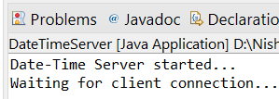

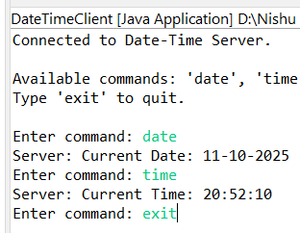

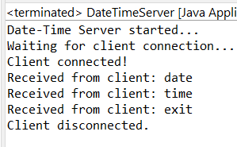

# 2. Remote Procedure Call:

## 1. Implement a Server calculator containing ADD (), MUL (), SUB () etc.

### CalculatorServer.java:

package socket_prac;

import java.io.*;

import java.net.*;

public class CalculatorServer {

public static void main(String[] args) {

try {

ServerSocket serverSocket = new ServerSocket(5000);

System.out.println("Server started. Waiting for client connection...");

Socket socket = serverSocket.accept();

System.out.println("Client connected!");

BufferedReader input = new BufferedReader(new InputStreamReader(socket.getInputStream()));

PrintWriter output = new PrintWriter(socket.getOutputStream(), true);

String clientRequest;

while ((clientRequest = input.readLine()) != null) {

if (clientRequest.equalsIgnoreCase("exit")) {

System.out.println("Client disconnected.");

break;

}

System.out.println("Received from client: " + clientRequest);

String[] parts = clientRequest.split(" ");

if (parts.length != 3) {

output.println("Invalid format! Use: OPERATION num1 num2");

continue;

}

String operation = parts[0].toUpperCase();

double num1 = Double.parseDouble(parts[1]);

double num2 = Double.parseDouble(parts[2]);

double result = 0.0;

switch (operation) {

case "ADD":

result = num1 + num2;

break;

case "SUB":

result = num1 - num2;

break;

case "MUL":

result = num1 * num2;

break;

case "DIV":

if (num2 == 0) {

output.println("Error: Division by zero!");

continue;

}

result = num1 / num2;

break;

default:

output.println("Unknown operation. Use ADD, SUB, MUL, or DIV.");

continue;

}

output.println("Result: " + result);

}

input.close();

output.close();

socket.close();

serverSocket.close();

} catch (IOException e) {

System.out.println("Server Error: " + e.getMessage());

}

}

}

### CalculatorClient.java:

package socket_prac;

import java.io.*;

import java.net.*;

import java.util.*;

public class CalculatorClient {

public static void main(String[] args) {

try {

Socket socket = new Socket("localhost", 5000);

System.out.println("Connected to Calculator Server.");

BufferedReader input = new BufferedReader(new InputStreamReader(socket.getInputStream()));

PrintWriter output = new PrintWriter(socket.getOutputStream(), true);

Scanner scanner = new Scanner(System.in);

System.out.println("\nAvailable operations: ADD, SUB, MUL, DIV");

System.out.println("Format: OPERATION num1 num2 (e.g., ADD 5 10)");

System.out.println("Type 'exit' to quit.\n");

String userInput;

while (true) {

System.out.print("Enter command: ");

userInput = scanner.nextLine();

output.println(userInput);

if (userInput.equalsIgnoreCase("exit")) {

System.out.println("Closing connection...");

break;

}

String response = input.readLine();

System.out.println("Server: " + response);

}

scanner.close();

input.close();

output.close();

socket.close();

} catch (IOException e) {

System.out.println("Client Error: " + e.getMessage());

}

}

}

### Output:







## 2. Implement a Date Time Server containing date() and time()

### DateTimeServer.java:

package socket_prac;

import java.io.*;

import java.net.*;

import java.time.LocalDate;

import java.time.LocalTime;

import java.time.format.DateTimeFormatter;

public class DateTimeServer {

public static void main(String[] args) {

try {

ServerSocket serverSocket = new ServerSocket(5001);

System.out.println("Date-Time Server started...");

System.out.println("Waiting for client connection...");

Socket socket = serverSocket.accept();

System.out.println("Client connected!");

BufferedReader input = new BufferedReader(new InputStreamReader(socket.getInputStream()));

PrintWriter output = new PrintWriter(socket.getOutputStream(), true);

String clientRequest;

while ((clientRequest = input.readLine()) != null) {

System.out.println("Received from client: " + clientRequest);

if (clientRequest.equalsIgnoreCase("exit")) {

output.println("Connection closed. Goodbye!");

System.out.println("Client disconnected.");

break;

}

switch (clientRequest.toLowerCase()) {

case "date":

LocalDate date = LocalDate.now();

output.println("Current Date: " + date.format(DateTimeFormatter.ofPattern("dd-MM-yyyy")));

break;

case "time":

LocalTime time = LocalTime.now();

output.println("Current Time: " + time.format(DateTimeFormatter.ofPattern("HH:mm:ss")));

break;

default:

output.println("Invalid command! Use 'date' or 'time'.");

break;

}

}

input.close();

output.close();

socket.close();

serverSocket.close();

} catch (IOException e) {

System.out.println("Server Error: " + e.getMessage());

}

}

}

### DateTimeClient.java:

package socket_prac;

import java.io.*;

import java.net.*;

import java.util.Scanner;

public class DateTimeClient {

public static void main(String[] args) {

try {

Socket socket = new Socket("localhost", 5001);

System.out.println("Connected to Date-Time Server.");

BufferedReader input = new BufferedReader(new InputStreamReader(socket.getInputStream()));

PrintWriter output = new PrintWriter(socket.getOutputStream(), true);

Scanner scanner = new Scanner(System.in);

System.out.println("\nAvailable commands: 'date', 'time'");

System.out.println("Type 'exit' to quit.\n");

String userInput;

while (true) {

System.out.print("Enter command: ");

userInput = scanner.nextLine();

output.println(userInput);

if (userInput.equalsIgnoreCase("exit")) {

System.out.println("Closing connection...");

break;

}

String response = input.readLine();

System.out.println("Server: " + response);

}

scanner.close();

input.close();

output.close();

socket.close();

} catch (IOException e) {

System.out.println("Client Error: " + e.getMessage());

}

}

}

### Output:







## 3. Implement a Server to do the following: 1. User will enter two values in hours and minutes from the client (Eg: 3 hour 40 minutes and 2 hour 50 minutes) 2. Server will add hour and minute components separately The client side receives the result and display the value i. only in hours ii. only in minutes

### TimeAdditionServer.java

package socket_prac;

import java.io.*;

import java.net.*;

public class TimeAdditionServer {

public static void main(String[] args) {

try {

ServerSocket serverSocket = new ServerSocket(5002);

System.out.println("Time Addition Server started...");

System.out.println("Waiting for client connection...");

Socket socket = serverSocket.accept();

System.out.println("Client connected!");

BufferedReader input = new BufferedReader(new InputStreamReader(socket.getInputStream()));

PrintWriter output = new PrintWriter(socket.getOutputStream(), true);

String data = input.readLine();

System.out.println("Received from client: " + data);

String[] parts = data.split(" ");

if (parts.length != 4) {

output.println("Invalid input! Send data as: h1 m1 h2 m2");

} else {

int h1 = Integer.parseInt(parts[0]);

int m1 = Integer.parseInt(parts[1]);

int h2 = Integer.parseInt(parts[2]);

int m2 = Integer.parseInt(parts[3]);

int totalMinutes = m1 + m2;

int totalHours = h1 + h2;

totalHours += totalMinutes / 60;

totalMinutes = totalMinutes % 60;

int totalInMinutes = totalHours * 60 + totalMinutes;

String resultInHours = String.format("%02d:%02d Hours", totalHours, totalMinutes);

String resultInMinutes = totalInMinutes + " Minutes";

output.println("Result in Hours: " + resultInHours);

output.println("Result in Minutes: " + resultInMinutes);

}

input.close();

output.close();

socket.close();

serverSocket.close();

System.out.println("Server closed.");

} catch (IOException e) {

System.out.println("Server Error: " + e.getMessage());

}

}

}

### TimeAdditionClient.java:

package socket_prac;

import java.io.*;

import java.net.*;

import java.util.Scanner;

public class TimeAdditionClient {

public static void main(String[] args) {

try {

Socket socket = new Socket("localhost", 5002);

System.out.println("Connected to Time Addition Server.");

BufferedReader input = new BufferedReader(new InputStreamReader(socket.getInputStream()));

PrintWriter output = new PrintWriter(socket.getOutputStream(), true);

Scanner scanner = new Scanner(System.in);

System.out.println("Enter first time:");

System.out.print("Hours: ");

int h1 = scanner.nextInt();

System.out.print("Minutes: ");

int m1 = scanner.nextInt();

System.out.println("Enter second time:");

System.out.print("Hours: ");

int h2 = scanner.nextInt();

System.out.print("Minutes: ");

int m2 = scanner.nextInt();

String data = h1 + " " + m1 + " " + h2 + " " + m2;

output.println(data);

String response1 = input.readLine();

String response2 = input.readLine();

System.out.println("\n" + response1);

System.out.println(response2);

scanner.close();

input.close();

output.close();

socket.close();

} catch (IOException e) {

System.out.println("Client Error: " + e.getMessage());

}

}

}

### Output:

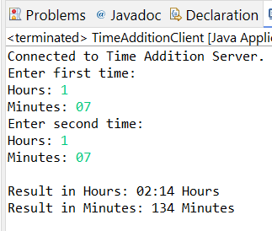

## 4. Implement a Server to do the following i. Get a string from the client. ii. Find the reverse of the string at the server side iii. The client side receives the reversed string and verifying whether it is palindrome

### ReverseServer.java:

import java.io.*;

import java.net.*;

public class ReverseServer {

public static void main(String[] args) {

try {

ServerSocket serverSocket = new ServerSocket(5000);

System.out.println("Reverse Server started...");

Socket socket = serverSocket.accept();

System.out.println("Client connected!");

BufferedReader input = new BufferedReader(new InputStreamReader(socket.getInputStream()));

PrintWriter output = new PrintWriter(socket.getOutputStream(), true);

String str = input.readLine();

String reversed = new StringBuilder(str).reverse().toString();

output.println(reversed);

input.close();

output.close();

socket.close();

serverSocket.close();

} catch (IOException e) {

System.out.println("Server Error: " + e.getMessage());

}

}

}

### ReverseClient.java:

import java.io.*;

import java.net.*;

import java.util.Scanner;

public class ReverseClient {

public static void main(String[] args) {

try {

Socket socket = new Socket("localhost", 5000);

BufferedReader input = new BufferedReader(new InputStreamReader(socket.getInputStream()));

PrintWriter output = new PrintWriter(socket.getOutputStream(), true);

Scanner scanner = new Scanner(System.in);

System.out.print("Enter a string: ");

String userInput = scanner.nextLine();

output.println(userInput);

String reversed = input.readLine();

System.out.println("Reversed string from server: " + reversed);

if (userInput.equalsIgnoreCase(reversed))

System.out.println("Result: The string is a Palindrome!");

else

System.out.println("Result: The string is NOT a Palindrome!");

scanner.close();

input.close();

output.close();

socket.close();

} catch (IOException e) {

System.out.println("Client Error: " + e.getMessage());

}

}

}

### Output:

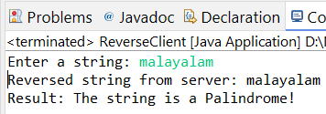

## 5.Implement a Server to do the following i. Get one number from the client. ii. Server will find whether the number from client is odd or even iii. After receiving the result from server client displays the message iv. If the number is even client will calculate the table of the number

### OddEvenServer.java:

import java.io.*;

import java.net.*;

public class OddEvenServer {

public static void main(String[] args) {

try {

ServerSocket serverSocket = new ServerSocket(5000);

System.out.println("Odd-Even Server started...");

Socket socket = serverSocket.accept();

System.out.println("Client connected.");

BufferedReader input = new BufferedReader(new InputStreamReader(socket.getInputStream()));

PrintWriter output = new PrintWriter(socket.getOutputStream(), true);

String numStr = input.readLine();

int num = Integer.parseInt(numStr);

String result = (num % 2 == 0) ? "even" : "odd";

output.println(result);

input.close();

output.close();

socket.close();

serverSocket.close();

} catch (IOException e) {

System.out.println("Server Error: " + e.getMessage());

}

}

}

### OddEvenClient.java:

import java.io.*;

import java.net.*;

import java.util.Scanner;

public class OddEvenClient {

public static void main(String[] args) {

try {

Socket socket = new Socket("localhost", 5000);

BufferedReader input = new BufferedReader(new InputStreamReader(socket.getInputStream()));

PrintWriter output = new PrintWriter(socket.getOutputStream(), true);

Scanner scanner = new Scanner(System.in);

System.out.print("Enter a number: ");

int num = scanner.nextInt();

output.println(num);

String response = input.readLine();

System.out.println("Server says: The number is " + response);

if (response.equalsIgnoreCase("even")) {

System.out.println("Multiplication Table of " + num + ":");

for (int i = 1; i <= 10; i++)

System.out.println(num + " x " + i + " = " + (num * i));

}

scanner.close();

input.close();

output.close();

socket.close();

} catch (IOException e) {

System.out.println("Client Error: " + e.getMessage());

}

}

}

### Output:

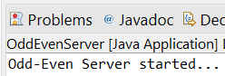

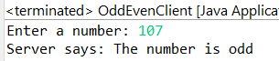

# 3. RMI BASED Exercise

## 1. Calculate addition of two numbers and send it to the client using RMI

### AdditionInterface.java (Remote Interface):

import java.rmi.Remote;

import java.rmi.RemoteException;

public interface AdditionInterface extends Remote {

int add(int a, int b) throws RemoteException;

}

### AdditionImpl.java (Remote Object Implementation):

import java.rmi.server.UnicastRemoteObject;

import java.rmi.RemoteException;

public class AdditionImpl extends UnicastRemoteObject implements AdditionInterface {

protected AdditionImpl() throws RemoteException {

super();

}

@Override

public int add(int a, int b) throws RemoteException {

return a + b;

}

}

### AdditionServer.java (RMI Server):

import java.rmi.Naming;

import java.rmi.registry.LocateRegistry;

public class AdditionServer {

public static void main(String[] args) {

try {

LocateRegistry.createRegistry(1099); // Start RMI registry

AdditionImpl addition = new AdditionImpl();

Naming.rebind("rmi://localhost/AdditionService", addition);

System.out.println("Addition RMI Server is ready...");

} catch (Exception e) {

System.out.println("Server Error: " + e.getMessage());

}

}

}

### AdditionClient.java (RMI Client):

import java.rmi.Naming;

import java.util.Scanner;

public class AdditionClient {

public static void main(String[] args) {

try {

AdditionInterface addition = (AdditionInterface) Naming.lookup("rmi://localhost/AdditionService");

Scanner scanner = new Scanner(System.in);

System.out.print("Enter first number: ");

int a = scanner.nextInt();

System.out.print("Enter second number: ");

int b = scanner.nextInt();

int result = addition.add(a, b);

System.out.println("Result from server: " + result);

scanner.close();

} catch (Exception e) {

System.out.println("Client Error: " + e.getMessage());

}

}

}

### Output:

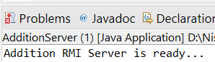

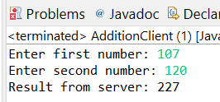

## 2. Retrieve time and date function from server to client. This program should display server date and time by implementing RMI

### TimeService.java (Remote Interface):

import java.rmi.Remote;

import java.rmi.RemoteException;

public interface TimeService extends Remote {

String getDateTime() throws RemoteException;

}

### TimeServiceImpl.java (Remote Object Implementation):

import java.rmi.server.UnicastRemoteObject;

import java.rmi.RemoteException;

import java.time.LocalDateTime;

import java.time.format.DateTimeFormatter;

public class TimeServiceImpl extends UnicastRemoteObject implements TimeService {

protected TimeServiceImpl() throws RemoteException {

super();

}

@Override

public String getDateTime() throws RemoteException {

LocalDateTime now = LocalDateTime.now();

DateTimeFormatter formatter = DateTimeFormatter.ofPattern("yyyy-MM-dd HH:mm:ss");

return now.format(formatter);

}

}

### TimeServer.java (RMI Server):

import java.rmi.Naming;

import java.rmi.registry.LocateRegistry;

public class TimeServer {

public static void main(String[] args) {

try {

LocateRegistry.createRegistry(1099); // Start RMI registry

TimeServiceImpl timeService = new TimeServiceImpl();

Naming.rebind("rmi://localhost/TimeService", timeService);

System.out.println("Time RMI Server is ready...");

} catch (Exception e) {

System.out.println("Server Error: " + e.getMessage());

}

}

}

### TimeClient.java (RMI Client):

import java.rmi.Naming;

public class TimeClient {

public static void main(String[] args) {

try {

TimeService timeService = (TimeService) Naming.lookup("rmi://localhost/TimeService");

String serverDateTime = timeService.getDateTime();

System.out.println("Server Date and Time: " + serverDateTime);

} catch (Exception e) {

System.out.println("Client Error: " + e.getMessage());

}

}

}

### Output:

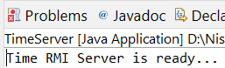

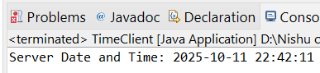

## 3. The client should provide the values of a and b. The server will solve the equation (a+b)2=a2+2ab+b2 and will give back the value of equation using RMI.

### EquationService.java (Remote Interface):

package RMI_based;

import java.rmi.Remote;

import java.rmi.RemoteException;

public interface EquationService extends Remote {

int solveEquation(int a, int b) throws RemoteException;

}

### EquationServiceImpl.java (Remote Object Implementation):

package RMI_based;

import java.rmi.server.UnicastRemoteObject;

import java.rmi.RemoteException;

public class EquationServiceImpl extends UnicastRemoteObject implements EquationService {

protected EquationServiceImpl() throws RemoteException {

super();

}

@Override

public int solveEquation(int a, int b) throws RemoteException {

// Using formula (a+b)^2 = a^2 + 2ab + b^2

return (a * a) + (2 * a * b) + (b * b);

}

}

### EquationServer.java (RMI Server):

package RMI_based;

import java.rmi.Naming;

import java.rmi.registry.LocateRegistry;

public class EquationServer {

public static void main(String[] args) {

try {

LocateRegistry.createRegistry(1099); // Start RMI registry

EquationServiceImpl equationService = new EquationServiceImpl();

Naming.rebind("rmi://localhost/EquationService", equationService);

System.out.println("Equation RMI Server is ready...");

} catch (Exception e) {

System.out.println("Server Error: " + e.getMessage());

}

}

}

### EquationClient.java (RMI Client):

package RMI_based;

import java.rmi.Naming;

import java.util.Scanner;

public class EquationClient {

public static void main(String[] args) {

try {

EquationService equationService = (EquationService) Naming.lookup("rmi://localhost/EquationService");

Scanner scanner = new Scanner(System.in);

System.out.print("Enter value of a: ");

int a = scanner.nextInt();

System.out.print("Enter value of b: ");

int b = scanner.nextInt();

int result = equationService.solveEquation(a, b);

System.out.println("Result of (a+b)^2 = a^2 + 2ab + b^2 is: " + result);

scanner.close();

} catch (Exception e) {

System.out.println("Client Error: " + e.getMessage());

}

}

}

### Output:

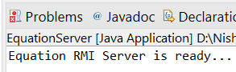

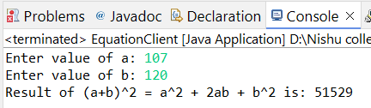

## 4. The client should provide the values of a and b. The server will solve the equation (a+b)2=a2+2ab+b2 and (a-b)2=a2+2ab+b2 and will give back the value of equation (Use RMI)

### EquationService.java (Remote Interface):

package RMI_based;

import java.rmi.Remote;

import java.rmi.RemoteException;

public interface EquationService extends Remote {

int solveEquation(int a, int b) throws RemoteException;

}

### EquationServiceImpl.java (Remote Object Implementation):

package RMI_based;

import java.rmi.server.UnicastRemoteObject;

import java.rmi.RemoteException;

public class EquationServiceImpl extends UnicastRemoteObject implements EquationService {

protected EquationServiceImpl() throws RemoteException {

super();

}

@Override

public int[] solveEquations(int a, int b) throws RemoteException {

int sumSquare = (a * a) + (2 * a * b) + (b * b); // (a+b)^2

int diffSquare = (a * a) - (2 * a * b) + (b * b); // (a-b)^2

return new int[]{sumSquare, diffSquare};

}

}

### EquationServer.java (RMI Server):

package RMI_based;

import java.rmi.Naming;

import java.rmi.registry.LocateRegistry;

public class EquationServer {

public static void main(String[] args) {

try {

LocateRegistry.createRegistry(1099); // Start RMI registry

EquationServiceImpl equationService = new EquationServiceImpl();

Naming.rebind("rmi://localhost/EquationService", equationService);

System.out.println("Equation RMI Server is ready...");

} catch (Exception e) {

System.out.println("Server Error: " + e.getMessage());

}

}

}

### EquationClient.java (RMI Client):

package RMI_based;

import java.rmi.Naming;

import java.util.Scanner;

public class EquationClient {

public static void main(String[] args) {

try {

EquationService equationService = (EquationService) Naming.lookup("rmi://localhost/EquationService");

Scanner scanner = new Scanner(System.in);

System.out.print("Enter value of a: ");

int a = scanner.nextInt();

System.out.print("Enter value of b: ");

int b = scanner.nextInt();

int[] results = equationService.solveEquations(a, b);

System.out.println("(a+b)^2 = " + results[0]);

System.out.println("(a-b)^2 = " + results[1]);

scanner.close();

} catch (Exception e) {

System.out.println("Client Error: " + e.getMessage());

}

}

}

### Output:

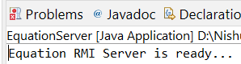

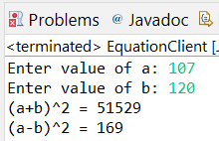

# 4.Remote Method Invocation (Graphical User Interface)

## 1. Design a Graphical User Interface for addition of two numbers. Implement using RMI

### AdditionService.java (Remote Interface):

package RMI_GUI;

import java.rmi.Remote;

import java.rmi.RemoteException;

public interface AdditionService extends Remote {

int add(int a, int b) throws RemoteException;

}

### AdditionServiceImpl.java (Remote Object Implementation):

package RMI_GUI;

import java.rmi.server.UnicastRemoteObject;

import java.rmi.RemoteException;

public class AdditionServiceImpl extends UnicastRemoteObject implements AdditionService {

protected AdditionServiceImpl() throws RemoteException {

super();

}

@Override

public int add(int a, int b) throws RemoteException {

return a + b;

}

}

### AdditionServer.java (RMI Server):

package RMI_GUI;

import java.rmi.Naming;

import java.rmi.registry.LocateRegistry;

public class AdditionServer {

public static void main(String[] args) {

try {

LocateRegistry.createRegistry(1099);

AdditionServiceImpl service = new AdditionServiceImpl();

Naming.rebind("rmi://localhost/AdditionService", service);

System.out.println("Addition RMI Server ready");

} catch (Exception e) {

System.out.println("Server Error: " + e.getMessage());

}

}

}

### AdditionClientGUI.java (RMI Client):

package RMI_GUI;

import javax.swing.*;

import java.awt.*;

import java.awt.event.*;

import java.rmi.Naming;

public class AdditionClientGUI extends JFrame {

private JTextField num1Field;

private JTextField num2Field;

private JButton addButton;

private JLabel resultLabel;

public AdditionClientGUI() {

setTitle("RMI Addition Client");

setSize(400, 200);

setLayout(new GridLayout(4, 2, 10, 10));

setDefaultCloseOperation(JFrame.EXIT_ON_CLOSE);

num1Field = new JTextField();

num2Field = new JTextField();

addButton = new JButton("Add");

resultLabel = new JLabel("Result: ");

add(new JLabel("Enter first number: "));

add(num1Field);

add(new JLabel("Enter second number: "));

add(num2Field);

add(addButton);

add(resultLabel);

addButton.addActionListener(new ActionListener() {

public void actionPerformed(ActionEvent e) {

try {

int a = Integer.parseInt(num1Field.getText());

int b = Integer.parseInt(num2Field.getText());

AdditionService service = (AdditionService) Naming.lookup("rmi://localhost/AdditionService");

int result = service.add(a, b);

resultLabel.setText("Result: " + result);

} catch (Exception ex) {

resultLabel.setText("Error: " + ex.getMessage());

}

}

});

setVisible(true);

}

public static void main(String[] args) {

new AdditionClientGUI();

}

}

### Output:

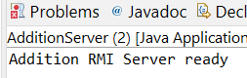

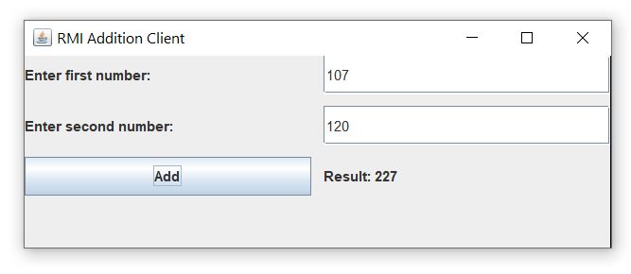

## 2. Design a Graphical User Interface (GUI) to find factorial of given numbers. Implement using RMI

### FactorialService.java (Remote Interface):

package RMI_GUI;

import java.rmi.Remote;

import java.rmi.RemoteException;

public interface FactorialService extends Remote {

long findFactorial(int n) throws RemoteException;

}

### FactorialServiceImpl.java (Remote Object Implementation):

package RMI_GUI;

import java.rmi.server.UnicastRemoteObject;

import java.rmi.RemoteException;

public class FactorialServiceImpl extends UnicastRemoteObject implements FactorialService {

protected FactorialServiceImpl() throws RemoteException {

super();

}

@Override

public long findFactorial(int n) throws RemoteException {

long fact = 1;

for (int i = 1; i <= n; i++)

fact *= i;

return fact;

}

}

### FactorialServer.java (RMI Server):

package RMI_GUI;

import java.rmi.Naming;

import java.rmi.registry.LocateRegistry;

public class FactorialServer {

public static void main(String[] args) {

try {

LocateRegistry.createRegistry(1099);

FactorialServiceImpl service = new FactorialServiceImpl();

Naming.rebind("rmi://localhost/FactorialService", service);

System.out.println("Factorial RMI Server ready");

} catch (Exception e) {

System.out.println("Server Error: " + e.getMessage());

}

}

}

### FactorialClientGUI.java (RMI Client):

package RMI_GUI;

import javax.swing.*;

import java.awt.*;

import java.awt.event.*;

import java.rmi.Naming;

public class FactorialClientGUI extends JFrame {

private JTextField inputField;

private JButton calcButton;

private JLabel resultLabel;

public FactorialClientGUI() {

setTitle("RMI Factorial Calculator");

setSize(400, 200);

setLayout(new GridLayout(3, 2, 10, 10));

setDefaultCloseOperation(JFrame.EXIT_ON_CLOSE);

inputField = new JTextField();

calcButton = new JButton("Find Factorial");

resultLabel = new JLabel("Result: ");

add(new JLabel("Enter a number: "));

add(inputField);

add(calcButton);

add(resultLabel);

calcButton.addActionListener(new ActionListener() {

public void actionPerformed(ActionEvent e) {

try {

int num = Integer.parseInt(inputField.getText());

FactorialService service = (FactorialService) Naming.lookup("rmi://localhost/FactorialService");

long fact = service.findFactorial(num);

resultLabel.setText("Result: " + fact);

} catch (Exception ex) {

resultLabel.setText("Error: " + ex.getMessage());

}

}

});

setVisible(true);

}

public static void main(String[] args) {

new FactorialClientGUI();

}

}

### Output:

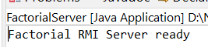

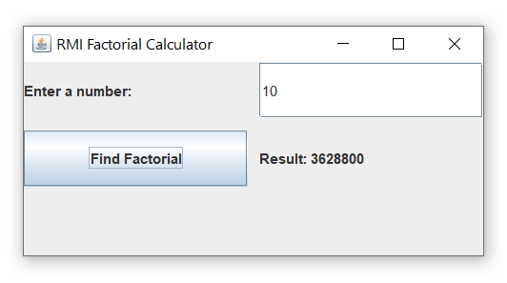

## 3. Design a Graphical User Interface (GUI) based Basic calculator by implementing RMI

### CalculatorService.java.java (Remote Interface):

import java.rmi.Remote;

import java.rmi.RemoteException;

public interface CalculatorService extends Remote {

double add(double a, double b) throws RemoteException;

double subtract(double a, double b) throws RemoteException;

double multiply(double a, double b) throws RemoteException;

double divide(double a, double b) throws RemoteException;

}

### CalculatorServiceImpl.java (Remote Object Implementation):

import java.rmi.server.UnicastRemoteObject;

import java.rmi.RemoteException;

public class CalculatorServiceImpl extends UnicastRemoteObject implements CalculatorService {

protected CalculatorServiceImpl() throws RemoteException {

super();

}

public double add(double a, double b) throws RemoteException {

return a + b;

}

public double subtract(double a, double b) throws RemoteException {

return a - b;

}

public double multiply(double a, double b) throws RemoteException {

return a * b;

}

public double divide(double a, double b) throws RemoteException {

if (b == 0) throw new RemoteException("Division by zero is not allowed");

return a / b;

}

}

### CalculatorServer.java (RMI Server):

package RMI_GUI;

import java.rmi.Naming;

import java.rmi.registry.LocateRegistry;

public class AdditionServer {

public static void main(String[] args) {

try {

LocateRegistry.createRegistry(1099);

AdditionServiceImpl service = new AdditionServiceImpl();

Naming.rebind("rmi://localhost/AdditionService", service);

System.out.println("Addition RMI Server ready");

} catch (Exception e) {

System.out.println("Server Error: " + e.getMessage());

}

}

}

### CalculatorClientGUI.java (RMI Client):

package RMI_GUI;

import javax.swing.*;

import java.awt.*;

import java.awt.event.*;

import java.rmi.Naming;

public class AdditionClientGUI extends JFrame {

private JTextField num1Field;

private JTextField num2Field;

private JButton addButton;

private JLabel resultLabel;

public AdditionClientGUI() {

setTitle("RMI Addition Client");

setSize(400, 200);

setLayout(new GridLayout(4, 2, 10, 10));

setDefaultCloseOperation(JFrame.EXIT_ON_CLOSE);

num1Field = new JTextField();

num2Field = new JTextField();

addButton = new JButton("Add");

resultLabel = new JLabel("Result: ");

add(new JLabel("Enter first number: "));

add(num1Field);

add(new JLabel("Enter second number: "));

add(num2Field);

add(addButton);

add(resultLabel);

addButton.addActionListener(new ActionListener() {

public void actionPerformed(ActionEvent e) {

try {

int a = Integer.parseInt(num1Field.getText());

int b = Integer.parseInt(num2Field.getText());

AdditionService service = (AdditionService) Naming.lookup("rmi://localhost/AdditionService");

int result = service.add(a, b);

resultLabel.setText("Result: " + result);

} catch (Exception ex) {

resultLabel.setText("Error: " + ex.getMessage());

}

}

});

setVisible(true);

}

public static void main(String[] args) {

new AdditionClientGUI();

}

}

### Output:

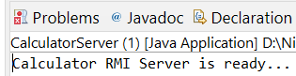

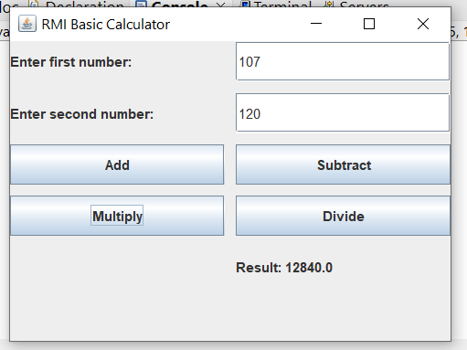

## 4. Design a Graphical User Interface (GUI) to find greatest of two numbers. Implement using RMI

### GreatestService.java (Remote Interface):

import java.rmi.Remote;

import java.rmi.RemoteException;

public interface GreatestService extends Remote {

int findGreatest(int a, int b) throws RemoteException;

}

### GreatestServiceImpl.java (Remote Object Implementation):

import java.rmi.server.UnicastRemoteObject;

import java.rmi.RemoteException;

public class GreatestServiceImpl extends UnicastRemoteObject implements GreatestService {

protected GreatestServiceImpl() throws RemoteException {

super();

}

public int findGreatest(int a, int b) throws RemoteException {

return a > b ? a : b;

}

}

### GreatestServer.java (RMI Server):

import java.rmi.Naming;

import java.rmi.registry.LocateRegistry;

public class GreatestServer {

public static void main(String[] args) {

try {

LocateRegistry.createRegistry(1099);

GreatestServiceImpl obj = new GreatestServiceImpl();

Naming.rebind("rmi://localhost/GreatestService", obj);

System.out.println("Greatest Number Server Ready...");

} catch (Exception e) {

System.out.println("Server Error: " + e.getMessage());

}

}

}

### GreatestClientGUI.java (RMI Client):

import javax.swing.*;

import java.awt.*;

import java.awt.event.*;

import java.rmi.Naming;

public class GreatestClientGUI extends JFrame {

private JTextField num1Field;

private JTextField num2Field;

private JLabel resultLabel;

private GreatestService service;

public GreatestClientGUI() {

setTitle("RMI Greatest of Two Numbers");

setSize(350, 250);

setLayout(new GridLayout(5, 2, 10, 10));

setDefaultCloseOperation(JFrame.EXIT_ON_CLOSE);

num1Field = new JTextField();

num2Field = new JTextField();

JButton findButton = new JButton("Find Greatest");

resultLabel = new JLabel("Result: ");

add(new JLabel("Enter first number:"));

add(num1Field);

add(new JLabel("Enter second number:"));

add(num2Field);

add(new JLabel());

add(findButton);

add(new JLabel());

add(resultLabel);

try {

service = (GreatestService) Naming.lookup("rmi://localhost/GreatestService");

} catch (Exception e) {

JOptionPane.showMessageDialog(this, "Error connecting to server: " + e.getMessage());

}

findButton.addActionListener(e -> {

try {

int a = Integer.parseInt(num1Field.getText());

int b = Integer.parseInt(num2Field.getText());

int result = service.findGreatest(a, b);

resultLabel.setText("Result: " + result + " is greatest");

} catch (Exception ex) {

resultLabel.setText("Error: " + ex.getMessage());

}

});

setVisible(true);

}

public static void main(String[] args) {

new GreatestClientGUI();

}

}

### Output:

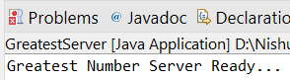

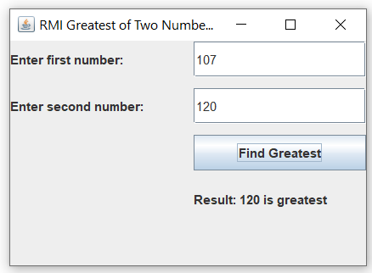

## 5. Design a Graphical User Interface (GUI) which accepts a numerical value from the client. Convert the number in to words. Implement using RMI

### NumberToWordsService.java (Remote Interface):

import java.rmi.Remote;

import java.rmi.RemoteException;

public interface NumberToWordsService extends Remote {

String convertNumberToWords(int number) throws RemoteException;

}

### NumberToWordsServiceImpl.java (Remote Object Implementation):

import java.rmi.server.UnicastRemoteObject;

import java.rmi.RemoteException;

public class NumberToWordsServiceImpl extends UnicastRemoteObject implements NumberToWordsService {

private static final String[] units = {

"", "One", "Two", "Three", "Four", "Five", "Six", "Seven", "Eight", "Nine", "Ten",

"Eleven", "Twelve", "Thirteen", "Fourteen", "Fifteen", "Sixteen",

"Seventeen", "Eighteen", "Nineteen"

};

private static final String[] tens = {

"", "", "Twenty", "Thirty", "Forty", "Fifty", "Sixty", "Seventy", "Eighty", "Ninety"

};

protected NumberToWordsServiceImpl() throws RemoteException {

super();

}

private String convert(int n) {

if (n < 20) return units[n];

if (n < 100) return tens[n / 10] + ((n % 10 != 0) ? " " + units[n % 10] : "");

if (n < 1000) return units[n / 100] + " Hundred" + ((n % 100 != 0) ? " and " + convert(n % 100) : "");

if (n < 1000000) return convert(n / 1000) + " Thousand" + ((n % 1000 != 0) ? " " + convert(n % 1000) : "");

return "Number too large";

}

public String convertNumberToWords(int number) throws RemoteException {

if (number == 0) return "Zero";

if (number < 0) return "Minus " + convert(-number);

return convert(number);

}

}

### NumberToWordsServer.java (RMI Server):

import java.rmi.Naming;

import java.rmi.registry.LocateRegistry;

public class NumberToWordsServer {

public static void main(String[] args) {

try {

LocateRegistry.createRegistry(1099);

NumberToWordsServiceImpl obj = new NumberToWordsServiceImpl();

Naming.rebind("rmi://localhost/NumberToWordsService", obj);

System.out.println("Number to Words Server Ready...");

} catch (Exception e) { System.out.println("Server Error: " + e.getMessage());

}

}

}

### NumberToWordsClientGUI.java (RMI Client):

import javax.swing.*;

import java.awt.*;

import java.awt.event.*;

import java.rmi.Naming;

public class NumberToWordsClientGUI extends JFrame {

private JTextField numberField;

private JLabel resultLabel;

private NumberToWordsService service;

public NumberToWordsClientGUI() {

setTitle("RMI Number to Words Converter");

setSize(400, 250);

setLayout(new GridLayout(4, 2, 10, 10));

setDefaultCloseOperation(JFrame.EXIT_ON_CLOSE);

numberField = new JTextField();

JButton convertButton = new JButton("Convert to Words");

resultLabel = new JLabel("Result: ");

add(new JLabel("Enter a Number:"));

add(numberField);

add(new JLabel());

add(convertButton);

add(new JLabel());

add(resultLabel);

try {

service = (NumberToWordsService) Naming.lookup("rmi://localhost/NumberToWordsService");

} catch (Exception e) {

JOptionPane.showMessageDialog(this, "Error connecting to server: " + e.getMessage());

}

convertButton.addActionListener(e -> {

try {

int num = Integer.parseInt(numberField.getText());

String result = service.convertNumberToWords(num);

resultLabel.setText("Result: " + result);

} catch (Exception ex) {

resultLabel.setText("Error: " + ex.getMessage());

}

});

setVisible(true);

}

public static void main(String[] args) {

new NumberToWordsClientGUI();

}

}

### Output:

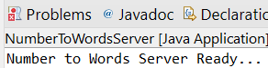

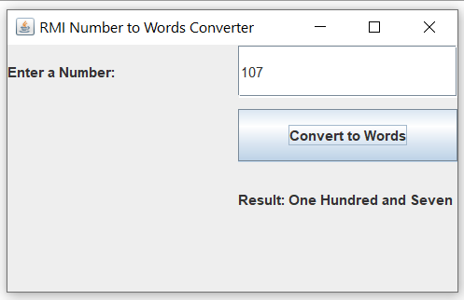

# 5. JDBC, Remote Object Communication & RMI

## Using MySQL create a Library database. Create table Book (Book_id, Book_name, Book_author) and retrieve the Book information from the Library database using the Remote Object Communication concept.

### Book.java:

package ROC;

import java.io.Serializable;

public class Book implements Serializable {

private int bookId;

private String bookName;

private String bookAuthor;

public Book(int bookId, String bookName, String bookAuthor) {

this.bookId = bookId;

this.bookName = bookName;

this.bookAuthor = bookAuthor;

}

public int getBookId() { return bookId; }

public String getBookName() { return bookName; }

public String getBookAuthor() { return bookAuthor; }

public String toString() {

return "Book ID: " + bookId + ", Title: " + bookName + ", Author: " + bookAuthor;

}

}

### LibraryService.java (Remote Interface):

package ROC;

import java.rmi.Remote;

import java.rmi.RemoteException;

import java.util.List;

public interface LibraryService extends Remote {

List<Book> getAllBooks() throws RemoteException;

}

### LibraryServer.java (RMI Server):

package ROC;

import java.rmi.Naming;

import java.rmi.registry.LocateRegistry;

public class LibraryServer {

public static void main(String[] args) {

try {

LocateRegistry.createRegistry(1099);

LibraryServiceImpl obj = new LibraryServiceImpl();

Naming.rebind("rmi://localhost/LibraryService", obj);

System.out.println("Library RMI Server Ready...");

} catch (Exception e) {

System.out.println("Server Error: " + e.getMessage());

}

}

}

### LibraryServiceImpl.java (Remote Object Implementation):

package ROC;

import java.rmi.server.UnicastRemoteObject;

import java.rmi.RemoteException;

import java.sql.*;

import java.util.ArrayList;

import java.util.List;

public class LibraryServiceImpl extends UnicastRemoteObject implements LibraryService {

Connection conn;

protected LibraryServiceImpl() throws RemoteException {

super();

try {

Class.forName("oracle.jdbc.driver.OracleDriver");

conn = DriverManager.getConnection(

"jdbc:oracle:thin:@localhost:1521:XE", "system", "nishant2711");

} catch (Exception e) {

System.out.println("Database connection error: " + e.getMessage());

}

}

public List<Book> getAllBooks() throws RemoteException {

List<Book> list = new ArrayList<>();

try {

Statement stmt = conn.createStatement();

ResultSet rs = stmt.executeQuery("SELECT * FROM Book");

while (rs.next()) {

list.add(new Book(rs.getInt("Book_id"), rs.getString("Book_name"), rs.getString("Book_author")));

}

} catch (Exception e) {

System.out.println("Error fetching books: " + e.getMessage());

}

return list;

}

}

### LibraryClient.java (RMI Client):

package ROC;

import java.rmi.Naming;

import java.util.List;

public class LibraryClient {

public static void main(String[] args) {

try {

LibraryService service = (LibraryService) Naming.lookup("rmi://localhost/LibraryService");

List<Book> books = service.getAllBooks();

System.out.println("Book Information from Library Database:\n");

for (Book b : books) {

System.out.println(b);

}

} catch (Exception e) {

System.out.println("Client Error: " + e.getMessage());

}

}

}

### Output:

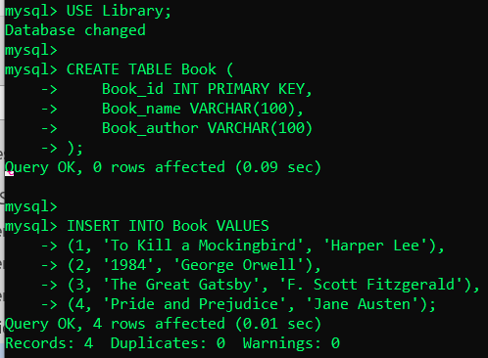

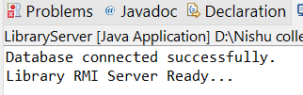

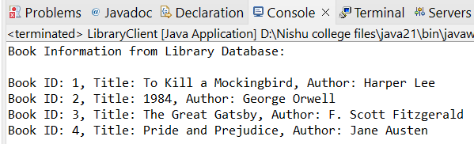

# 6. JDBC, Remote Object Communication & RMI

## Using MySQL create a Student database. Create table student_data(ID ,NAME , BRANCH ,PERCENTAGE ,EMAIL ) and retrieve the student_data information from Student database using Remote Object Communication concept.

### Student.java:

package ROC2;

import java.io.Serializable;

public class Student implements Serializable {

private int id; private String name;

private String branch; private float percentage;

private String email;

public Student(int id, String name, String branch, float percentage, String email) {

this.id = id; this.name = name;

this.branch = branch; this.percentage = percentage; this.email = email;

}

public int getId() { return id; }

public String getName() { return name; }

public String getBranch() { return branch; }

public float getPercentage() { return percentage; }

public String getEmail() { return email; }

public String toString() { return "ID: " + id + ", Name: " + name + ", Branch: " + branch +

", Percentage: " + percentage + ", Email: " + email;

}

}

### StudentService.java (Remote Interface):

package ROC2;

import java.rmi.Remote;

import java.rmi.RemoteException;

import java.util.List;

public interface StudentService extends Remote {

List<Student> getAllStudents() throws RemoteException;

}

### StudentServer.java (RMI Server):

package ROC2;

import java.rmi.Naming;

import java.rmi.registry.LocateRegistry;

public class StudentServer {

public static void main(String[] args) {

try {

System.setProperty("java.rmi.server.hostname","127.0.0.1");

LocateRegistry.createRegistry(1099);

StudentServiceImpl obj = new StudentServiceImpl();

Naming.rebind("rmi://127.0.0.1/StudentService", obj);

System.out.println("Student RMI Server Ready...");

} catch (Exception e) { e.printStackTrace();

}

}

}

### StudentServiceImpl.java (Remote Object Implementation):

package ROC2;

import java.rmi.server.UnicastRemoteObject;

import java.rmi.RemoteException;

import java.sql.*;

import java.util.ArrayList;

import java.util.List;

public class StudentServiceImpl extends UnicastRemoteObject implements StudentService {

Connection conn;

protected StudentServiceImpl() throws RemoteException {

super();

try {

Class.forName("com.mysql.cj.jdbc.Driver");

conn = DriverManager.getConnection(

"jdbc:mysql://localhost:3306/StudentDB", "root", "your_mysql_password");

System.out.println("Database connected successfully.");

} catch (Exception e) {

e.printStackTrace();

}

}

public List<Student> getAllStudents() throws RemoteException {

List<Student> list = new ArrayList<>();

try {

Statement stmt = conn.createStatement();

ResultSet rs = stmt.executeQuery("SELECT * FROM student_data");

while (rs.next()) {

list.add(new Student(

rs.getInt("ID"),

rs.getString("NAME"),

rs.getString("BRANCH"),

rs.getFloat("PERCENTAGE"),

rs.getString("EMAIL")

));

}

} catch (Exception e) {

e.printStackTrace();

}

return list;

}

}

### StudentClient.java (RMI Client):

package ROC2;

import java.rmi.Naming;

import java.util.List;

public class StudentClient {

public static void main(String[] args) {

try {

StudentService service = (StudentService) Naming.lookup("rmi://127.0.0.1/StudentService");

List<Student> students = service.getAllStudents();

System.out.println("Student Information from Database:\n");

for (Student s : students) { System.out.println(s); }

} catch (Exception e) { e.printStackTrace(); }

}

}

### Output:

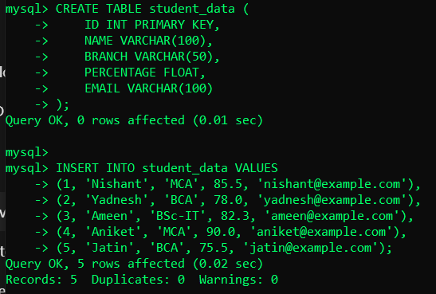

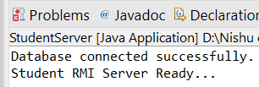

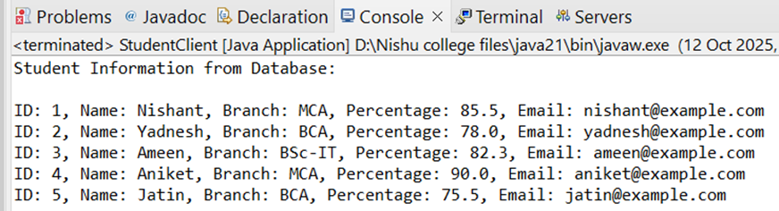

# 7. JDBC, Remote Object Communication & RMI

## Using MySQL create ElecrticBill database. Create table Bill(consumer_name, bill_due_date, bill_amount) and retrieve the Bill information from the ElecrticBill database using Remote Object Communication concept.

### Bill.java:

import java.io.Serializable;

import java.util.Date;

public class Bill implements Serializable {

private String consumerName;

private Date billDueDate;

private float billAmount;

public Bill(String consumerName, Date billDueDate, float billAmount) {

this.consumerName = consumerName;

this.billDueDate = billDueDate;

this.billAmount = billAmount;

}

public String getConsumerName() { return consumerName; }

public Date getBillDueDate() { return billDueDate; }

public float getBillAmount() { return billAmount; }

public String toString() {

return "Consumer: " + consumerName + ", Due Date: " + billDueDate + ", Amount: " + billAmount;

}

}

### BillService.java (Remote Interface):

import java.rmi.Remote;

import java.rmi.RemoteException;

import java.util.List;

public interface BillService extends Remote {

List<Bill> getAllBills() throws RemoteException;

}

### BillServer.java (RMI Server):

import java.rmi.Naming;

import java.rmi.registry.LocateRegistry;

public class BillServer {

public static void main(String[] args) {

try {

System.setProperty("java.rmi.server.hostname","127.0.0.1");

LocateRegistry.createRegistry(1099);

BillServiceImpl obj = new BillServiceImpl();

Naming.rebind("rmi://127.0.0.1/BillService", obj);

System.out.println("Bill RMI Server Ready...");

} catch (Exception e) {

e.printStackTrace();

}

}

}

### BillServiceImpl.java (Remote Object Implementation):

import java.rmi.server.UnicastRemoteObject;

import java.rmi.RemoteException;

import java.sql.*;

import java.util.ArrayList;

import java.util.List;

public class BillServiceImpl extends UnicastRemoteObject implements BillService {

Connection conn;

protected BillServiceImpl() throws RemoteException {

super();

try {

Class.forName("com.mysql.cj.jdbc.Driver");

conn = DriverManager.getConnection(

"jdbc:mysql://localhost:3306/ElectricBillDB", "root", " mysql_password");

System.out.println("Database connected successfully.");

} catch (Exception e) {

e.printStackTrace();

}

}

public List<Bill> getAllBills() throws RemoteException {

List<Bill> list = new ArrayList<>();

try {

Statement stmt = conn.createStatement();

ResultSet rs = stmt.executeQuery("SELECT * FROM Bill");

while (rs.next()) {

list.add(new Bill(

rs.getString("consumer_name"),

rs.getDate("bill_due_date"),

rs.getFloat("bill_amount")

));

}

} catch (Exception e) {

e.printStackTrace();

}

return list;

}

}

### BillClient.java (RMI Client):

import java.rmi.Naming;

import java.util.List;

public class BillClient {

public static void main(String[] args) {

try {

BillService service = (BillService) Naming.lookup("rmi://127.0.0.1/BillService");

List<Bill> bills = service.getAllBills();

System.out.println("Electric Bill Information:\n");

for (Bill b : bills) {

System.out.println(b);

}

} catch (Exception e) {

e.printStackTrace();

}

}

}

### Output:

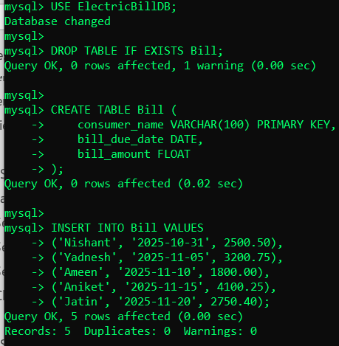

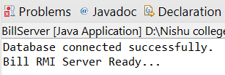

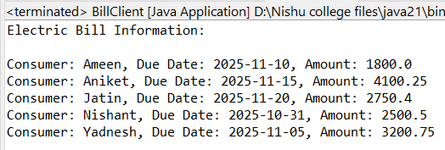

# 8.Implementation of mutual exclusion using Token ring algorithm.

### TokenRing.java:

class TokenRing {

private int numProcesses;

private volatile int tokenHolder = 0;

public TokenRing(int numProcesses) {

this.numProcesses = numProcesses;

}

public synchronized void requestToken(int processId) {

while (processId != tokenHolder) {

try {

wait();

} catch (InterruptedException e) {

e.printStackTrace();

}

}

}

public synchronized void releaseToken() {

tokenHolder = (tokenHolder + 1) % numProcesses;

notifyAll();

}

}

### Process.java:

class Process extends Thread {

private int id;

private TokenRing ring;

public Process(int id, TokenRing ring) {

this.id = id;

this.ring = ring;

}

@Override

public void run() {

while (true) {

ring.requestToken(id);

System.out.println("Process " + id + " has entered the critical section.");

try {

Thread.sleep(1000); // Simulate work

} catch (InterruptedException e) {

e.printStackTrace();

}

System.out.println("Process " + id + " is leaving the critical section.");

ring.releaseToken();

try { Thread.sleep(500); } catch (InterruptedException e) {

e.printStackTrace();

}

}

}

}

### TokenRingMain.java:

package prac9;

public class TokenRingMain {

public static void main(String[] args) {

int numProcesses = 5;

TokenRing ring = new TokenRing(numProcesses);

for (int i = 0; i < numProcesses; i++) {

new Process(i, ring).start();

}

}

}

### Output:

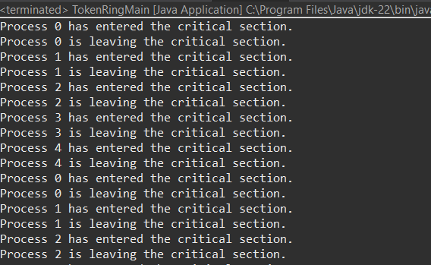

# 9.Implementation of Election Algorithm.

### Process.java:

package prac10;

public class Process extends Thread {

int id;

boolean isActive = true;

static int *coordinatorId* = -1;

Process[] processes;

public Process(int id, Process[] processes) {

this.id = id;

this.processes = processes;

}

public void fail() {

isActive = false;

System.***out***.println("Process " + id + " has failed.");

if (id == *coordinatorId*) {

System.***out***.println("Coordinator " + id + " has failed. Election will be triggered.");

*coordinatorId* = -1;

triggerElection();

}

}

public void recover() {

isActive = true;

System.***out***.println("Process " + id + " has recovered.");

triggerElection();

}

public void triggerElection() {

if (!isActive) return;

System.***out***.println("Process " + id + " is starting an election...");

boolean higherExists = false;

for (int i = id + 1; i < processes.length; i++) {

if (processes[i].isActive) {

System.***out***.println("Process " + id + " sends election to Process " + processes[i].id);

higherExists = true;

}

}

if (!higherExists) {

*coordinatorId* = id;

System.***out***.println("Process " + id + " becomes the coordinator.");

announceCoordinator();

}

}

public void announceCoordinator() {

for (Process p : processes) {

if (p.isActive) {

System.***out***.println("Process " + *coordinatorId* + " announces itself as coordinator to Process " + p.id);

}

}

}

*@Override*

public void run() {

try {

while (true) {

Thread.*sleep*((int)(Math.*random*() * 8000 + 2000)); // Random delay

double action = Math.*random*();

if (action < 0.3 && isActive) {

fail();

} else if (action < 0.6 && !isActive) {

recover();

} else if (action < 0.9 && isActive && *coordinatorId* == -1) {

triggerElection();

}

}

} catch (InterruptedException e) {

e.printStackTrace();

}

}

}

### ElectionMain.java:

package prac10;

public class ElectionMain {

public static void main(String[] args) {

int numProcesses = 5;

Process[] processes = new Process[numProcesses];

for (int i = 0; i < numProcesses; i++) {

processes[i] = new Process(i, processes);

}

System.***out***.println("Starting automatic Bully Election simulation...\n");

for (Process p : processes) {

p.start();

}

}

}

### Output:

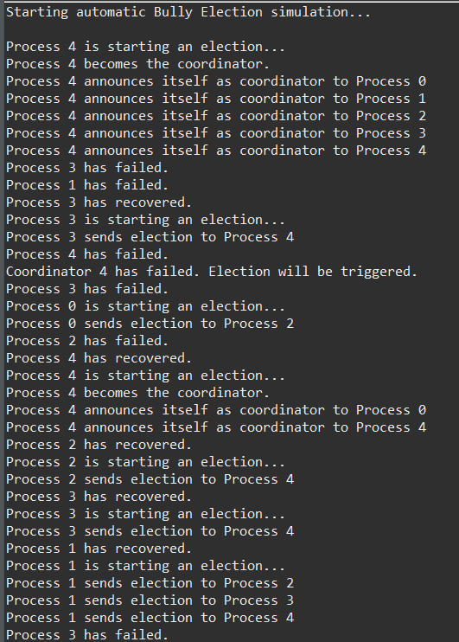

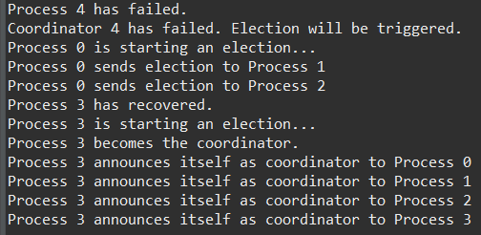

# 10. Implementation of Storage as a Service using Google Docs.

### TokenRing.java:

class TokenRing {

private int numProcesses;

private volatile int tokenHolder = 0;

public TokenRing(int numProcesses) {

this.numProcesses = numProcesses;

}

public synchronized void requestToken(int processId) {

while (processId != tokenHolder) {

try {

wait();

} catch (InterruptedException e) {

e.printStackTrace();

}

}

}

public synchronized void releaseToken() {

tokenHolder = (tokenHolder + 1) % numProcesses;

notifyAll();

}

}

### Process.java:

class Process extends Thread {

private int id;

private TokenRing ring;

public Process(int id, TokenRing ring) {

this.id = id;

this.ring = ring;

}

@Override

public void run() {

while (true) {

ring.requestToken(id);

System.out.println("Process " + id + " has entered the critical section.");

try {

Thread.sleep(1000); // Simulate work

} catch (InterruptedException e) {

e.printStackTrace();

}

System.out.println("Process " + id + " is leaving the critical section.");

ring.releaseToken();

try { Thread.sleep(500); } catch (InterruptedException e) {

e.printStackTrace();

}

}

}

}

### TokenRingMain.java:

package prac9;

public class TokenRingMain {

public static void main(String[] args) {

int numProcesses = 5;

TokenRing ring = new TokenRing(numProcesses);

for (int i = 0; i < numProcesses; i++) {

new Process(i, ring).start();

}

}

}

### Output:

# 11. Implementation of Identity Management.

### Output:

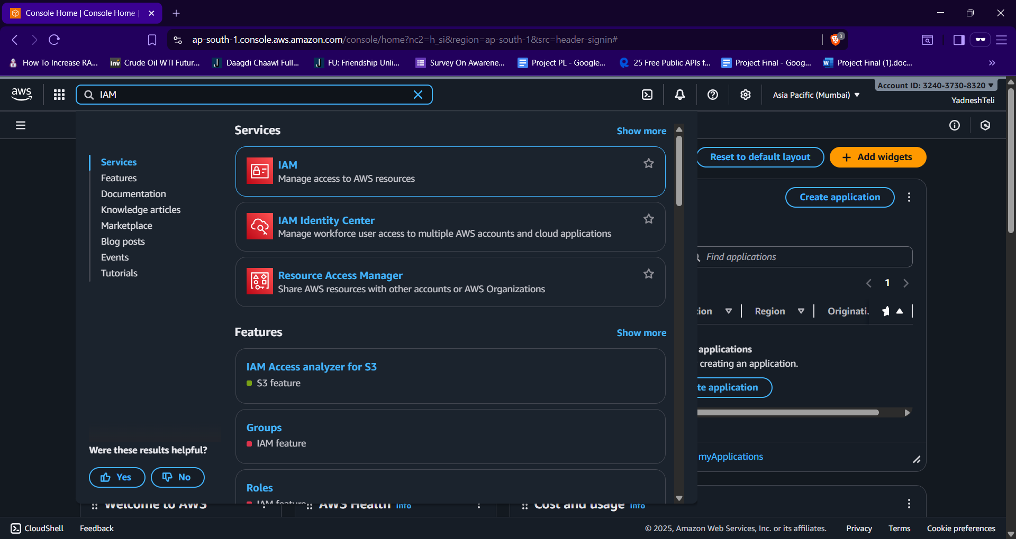

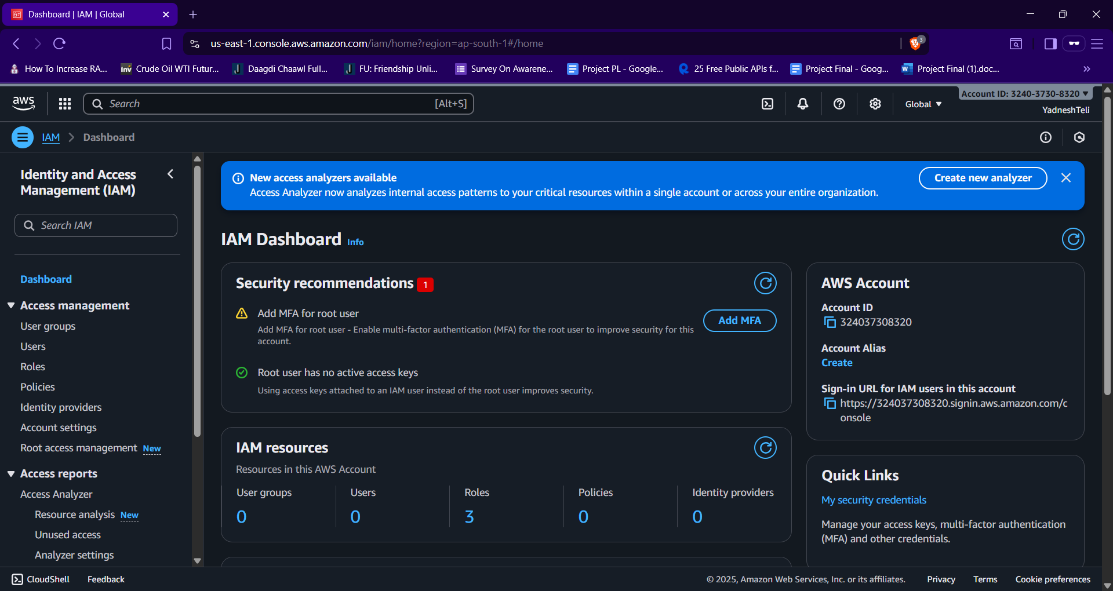

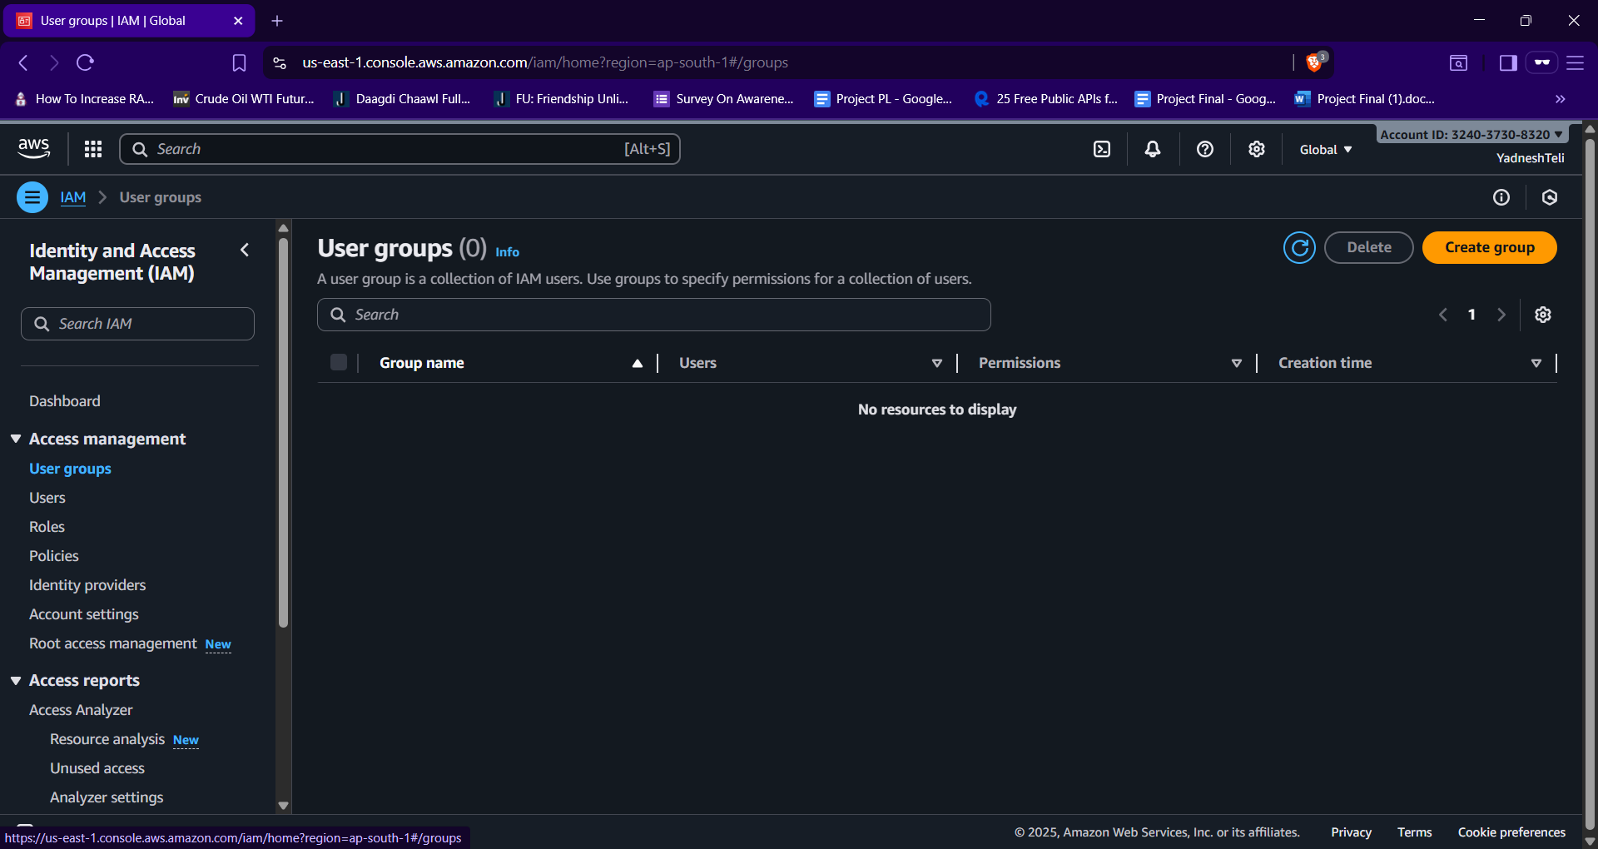

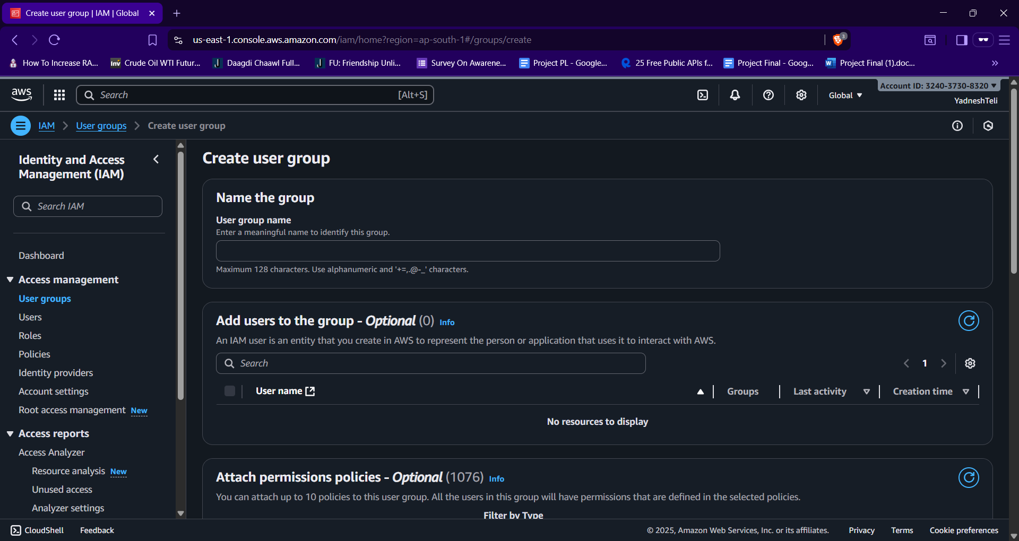

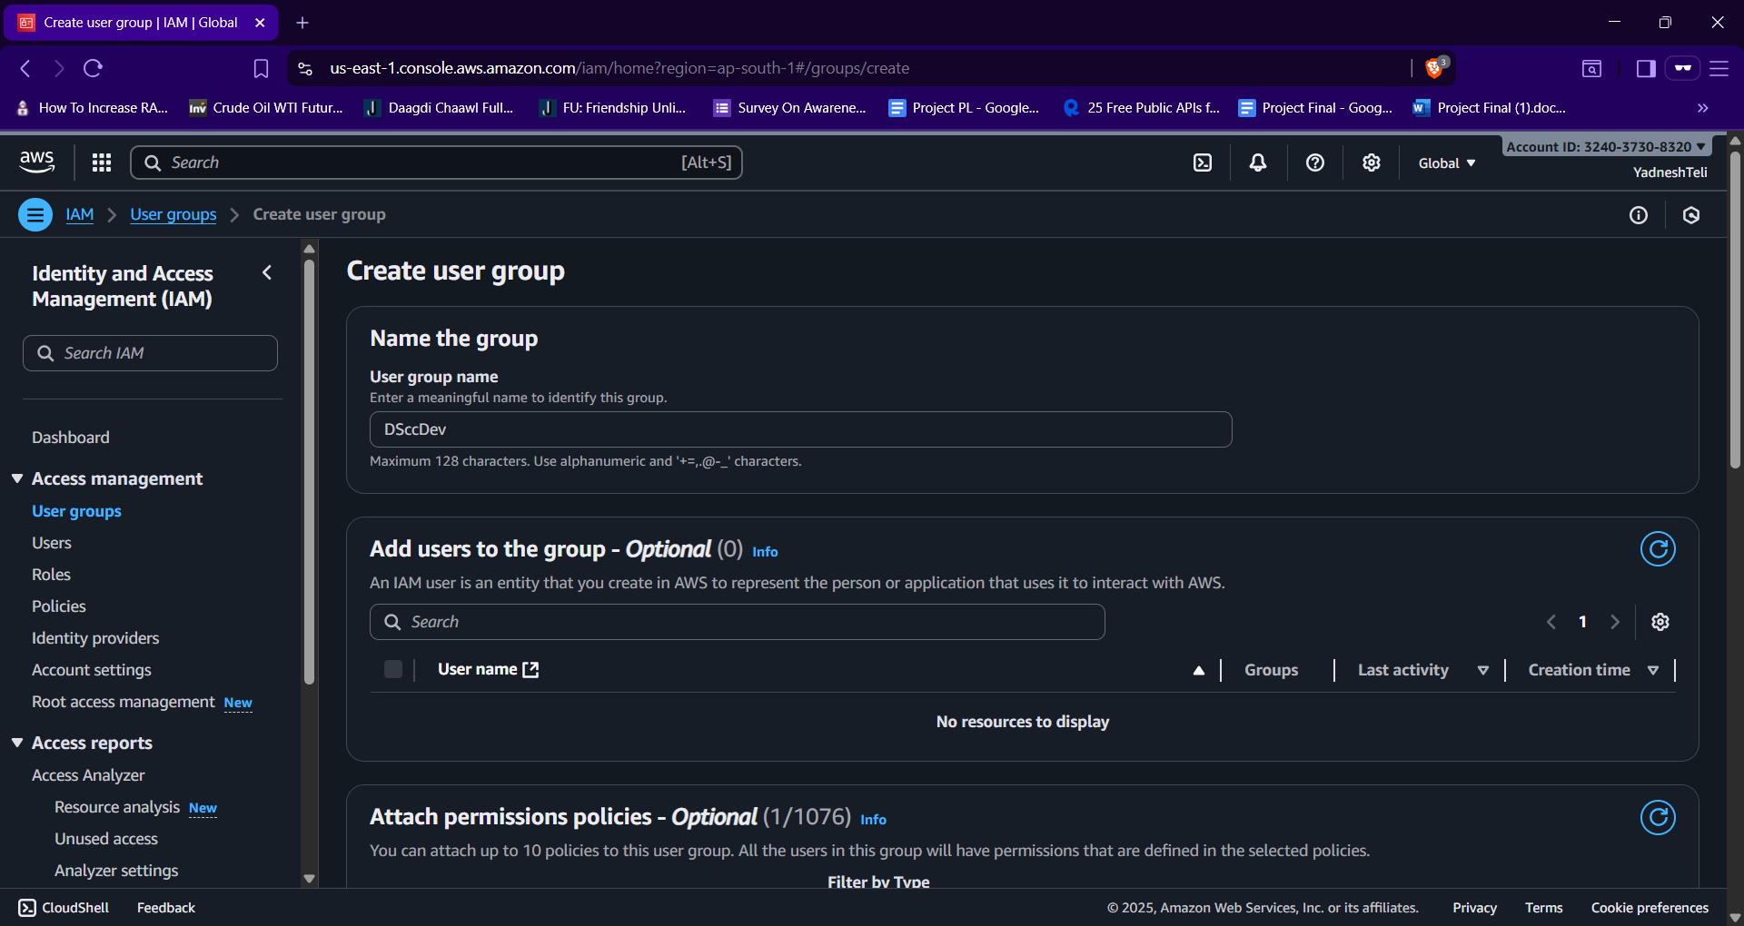

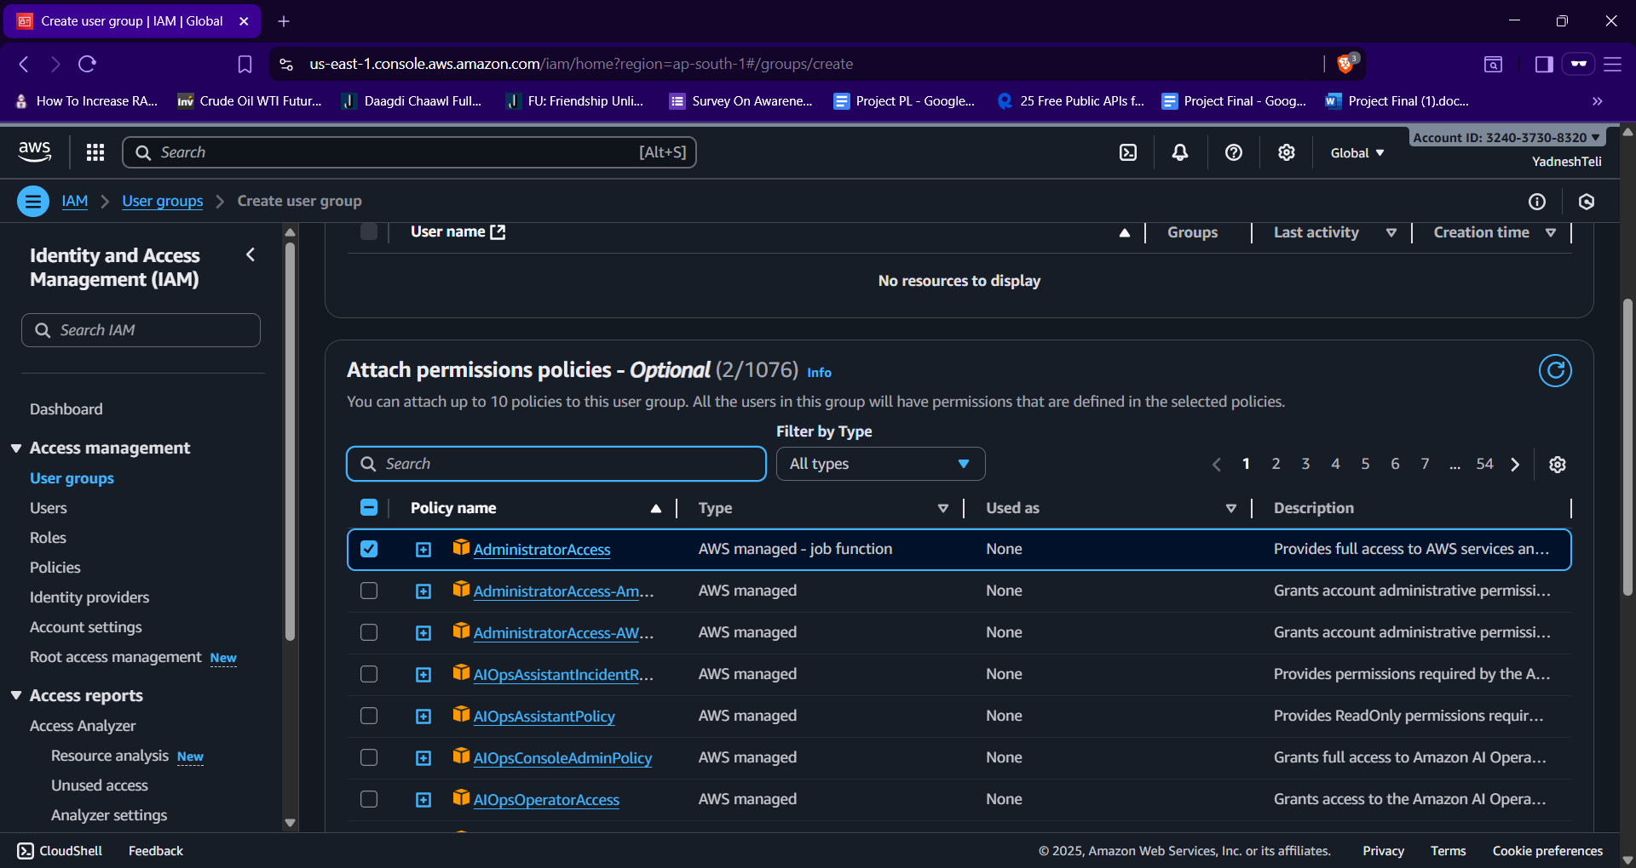

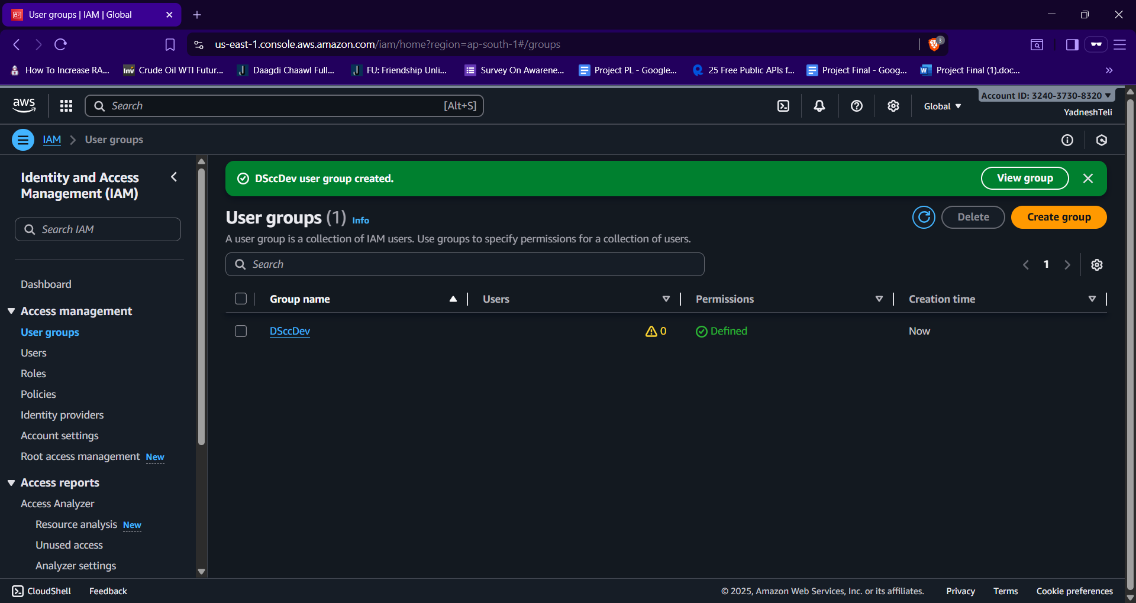

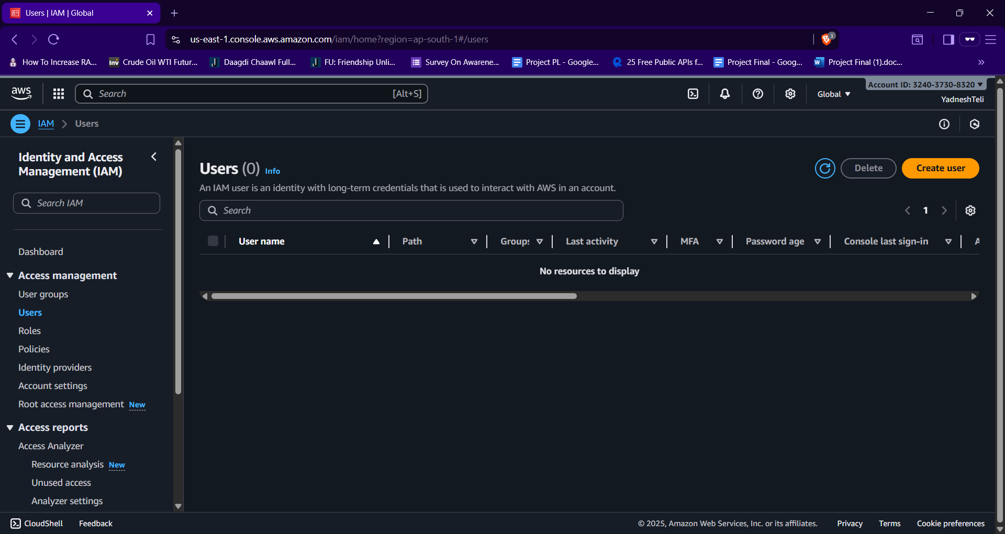

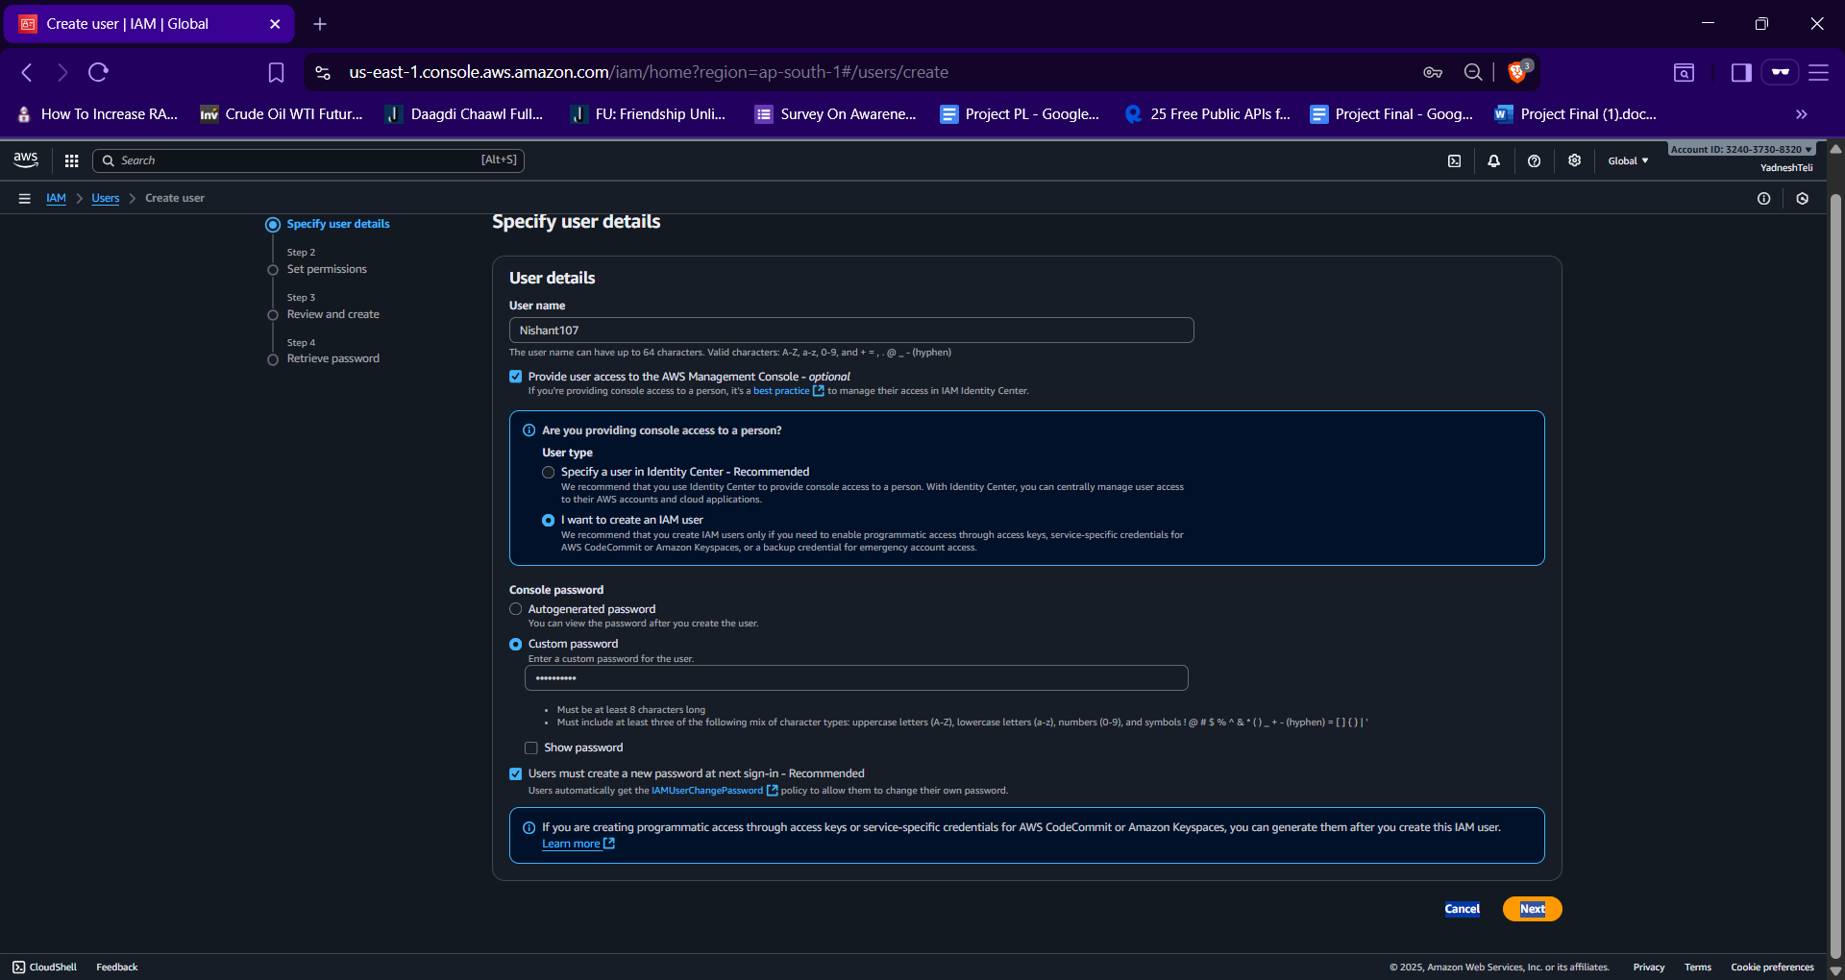

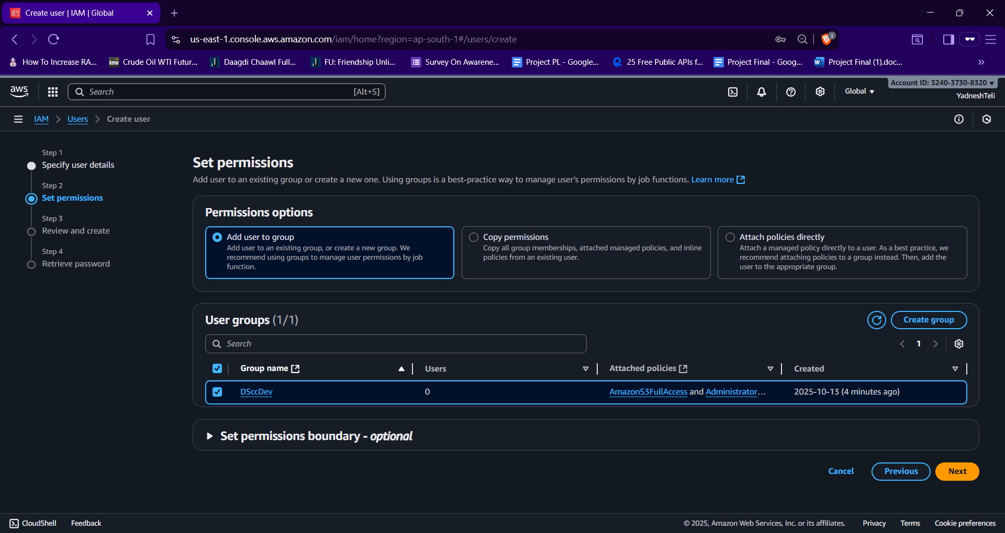

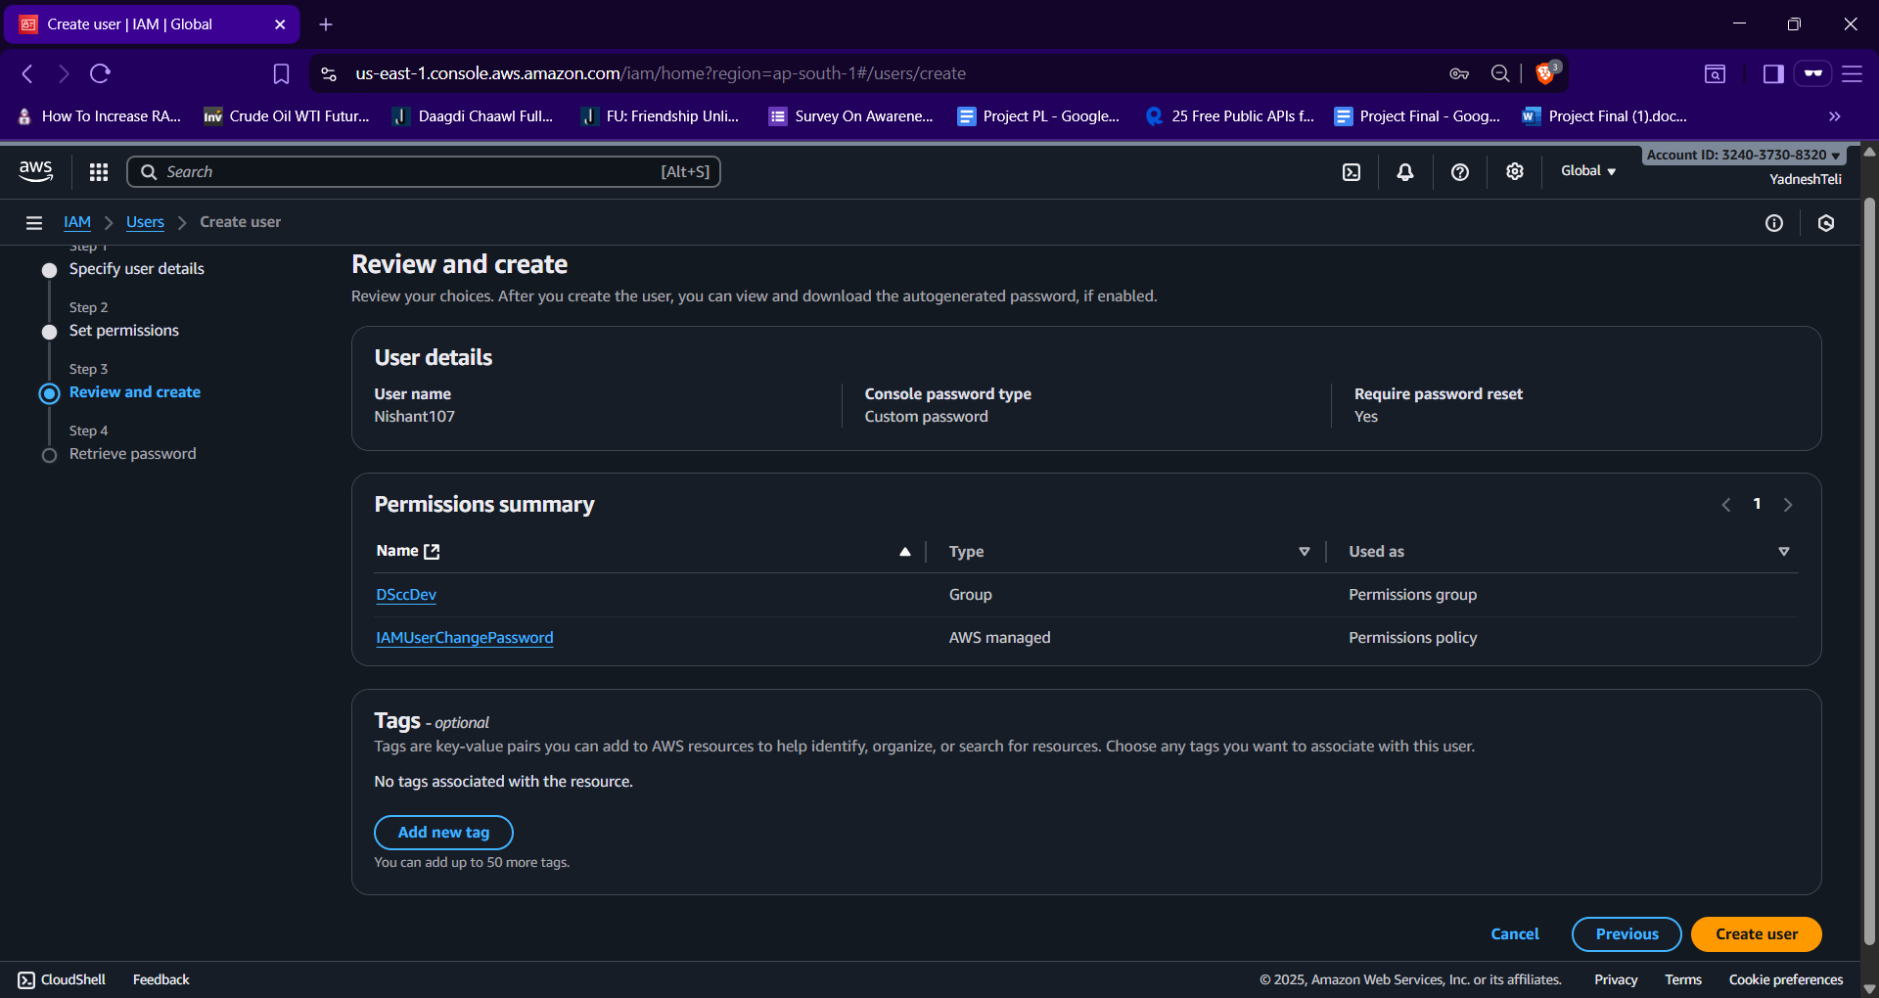

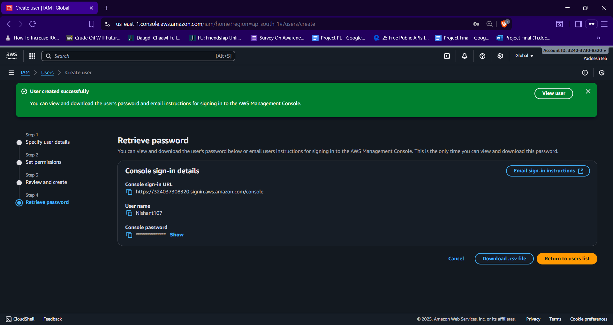

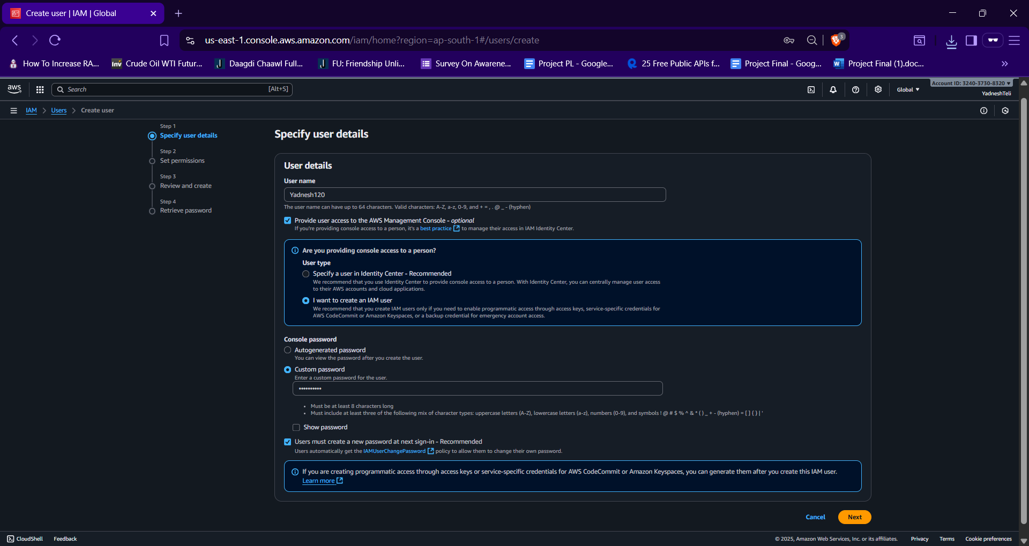

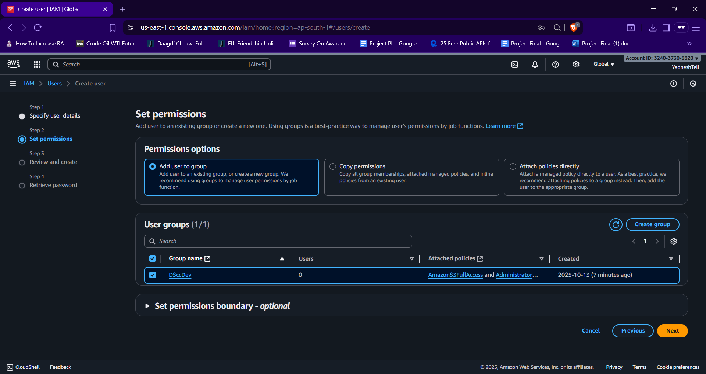

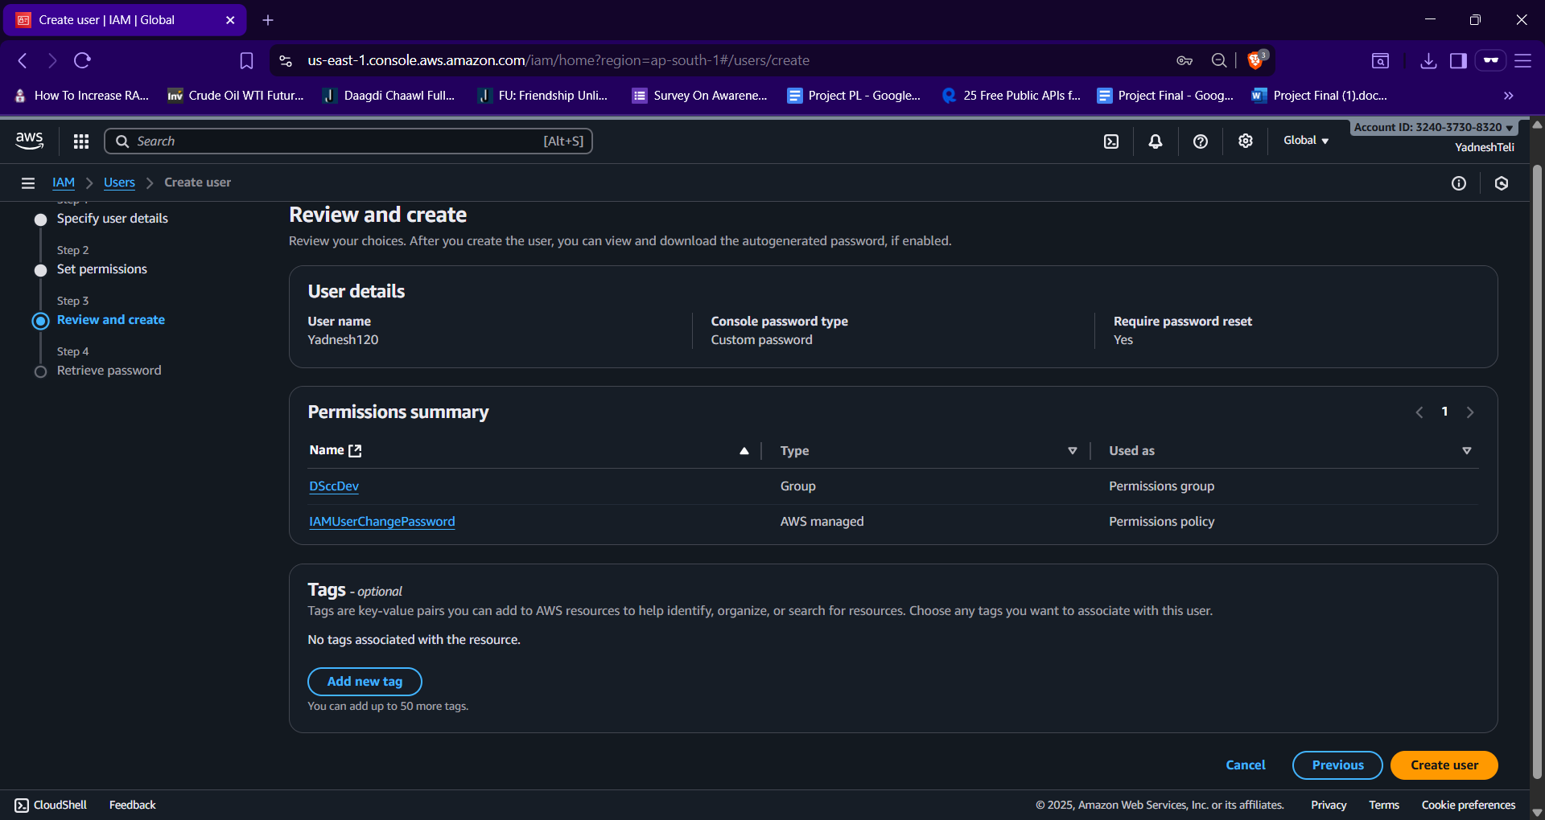

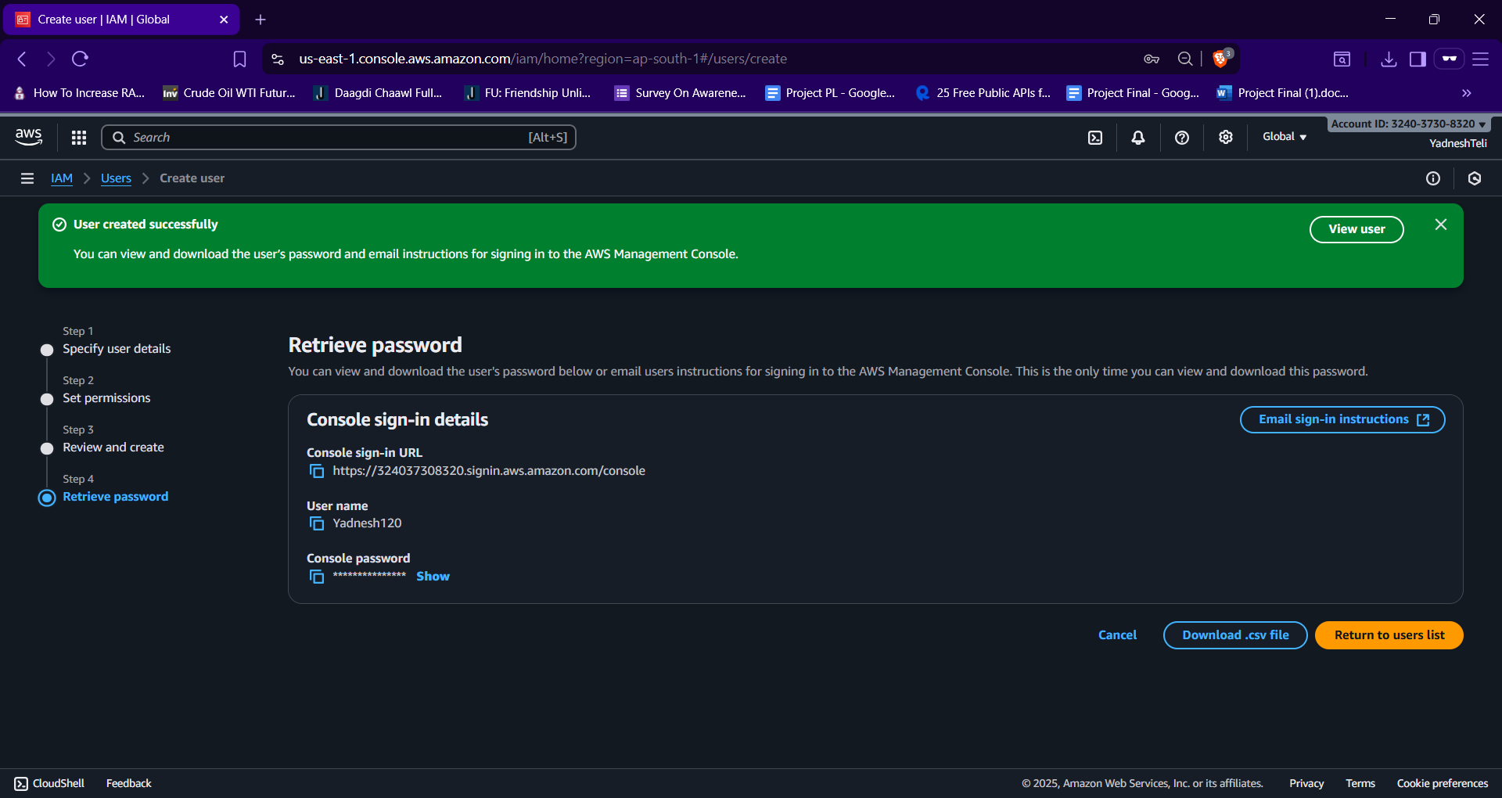

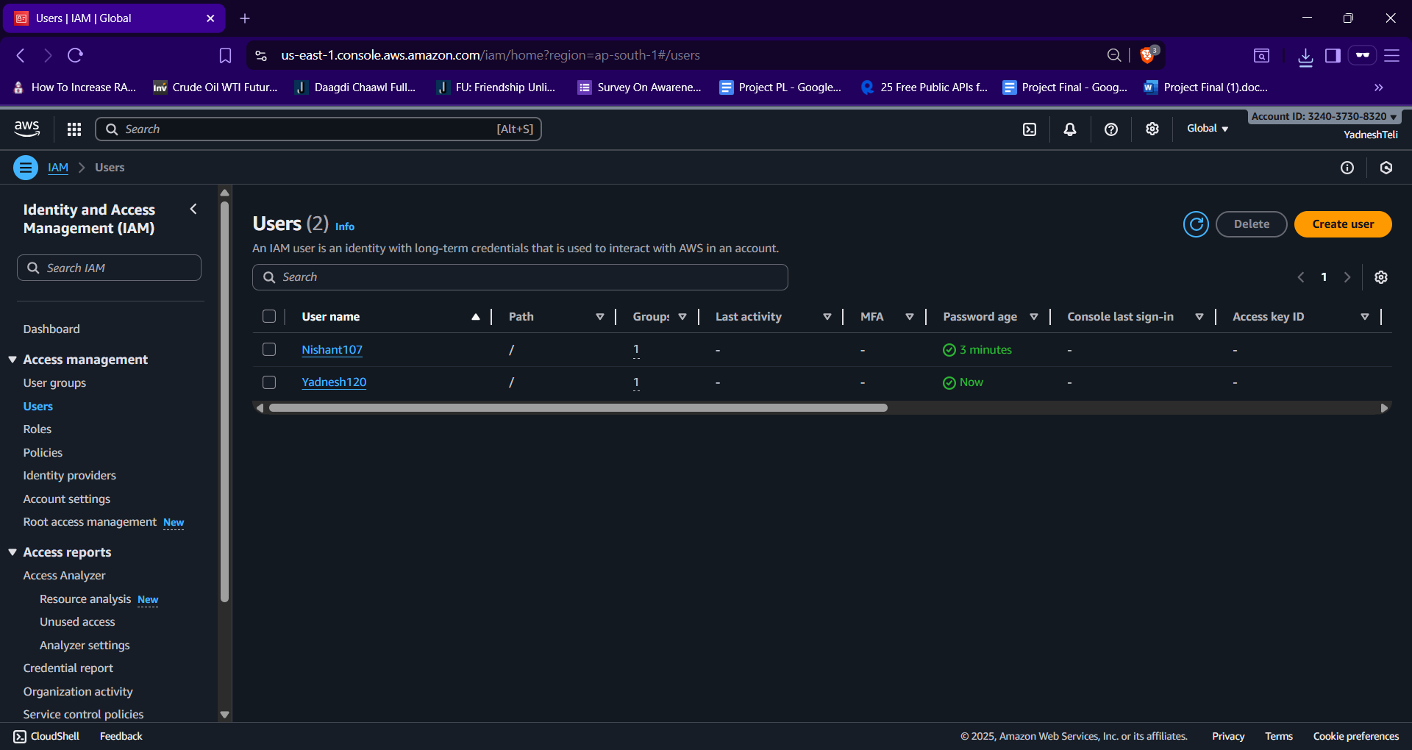

# 12. Create a virtual machine (VM) on any cloud provider ( AWS/Azure/GCP) of your choice with the specifications: Operating System, VM Type, Disk Size, Public IP, Network Rules Once created, verify that the VM is running and submit a screenshot of the instance details and a brief description of the steps you followed.

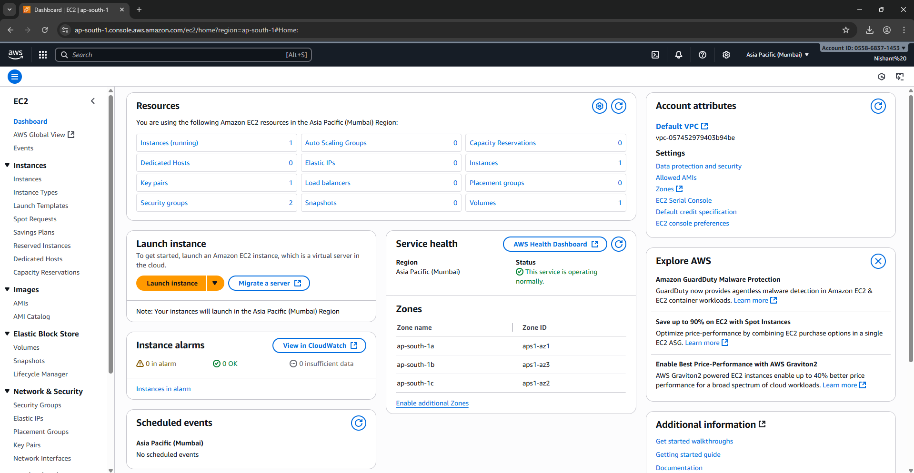

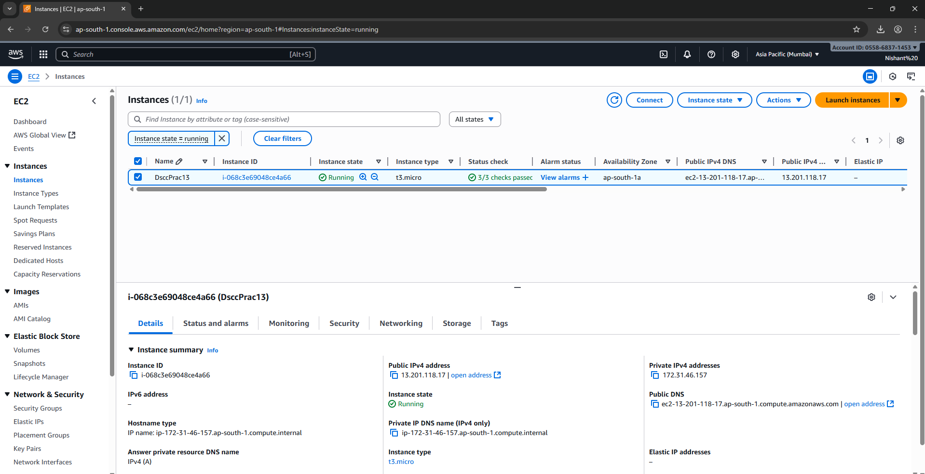

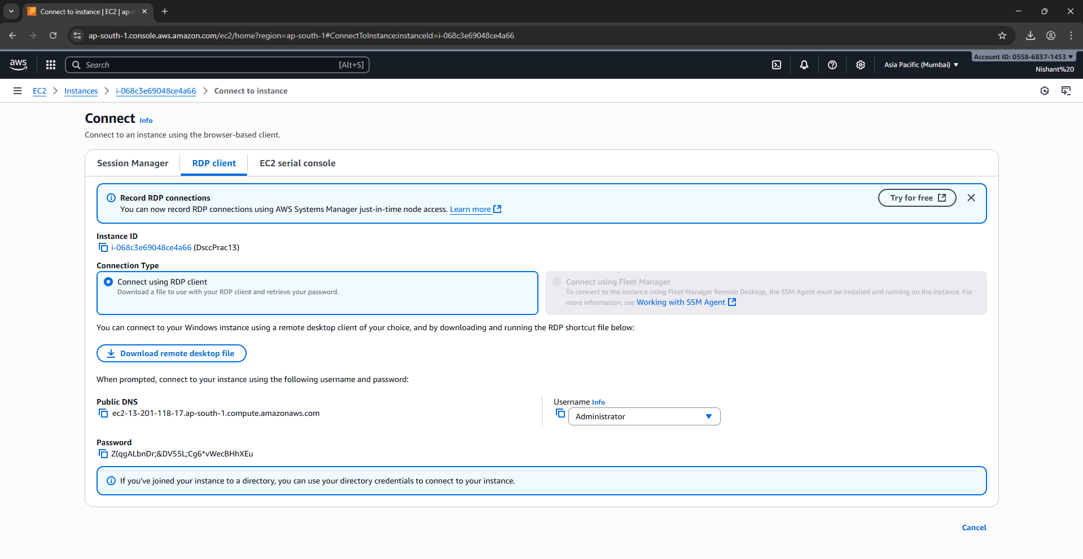

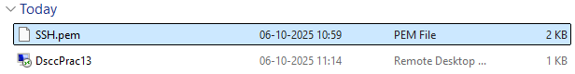

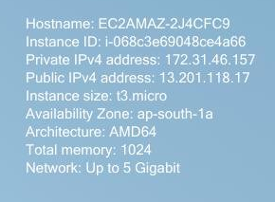

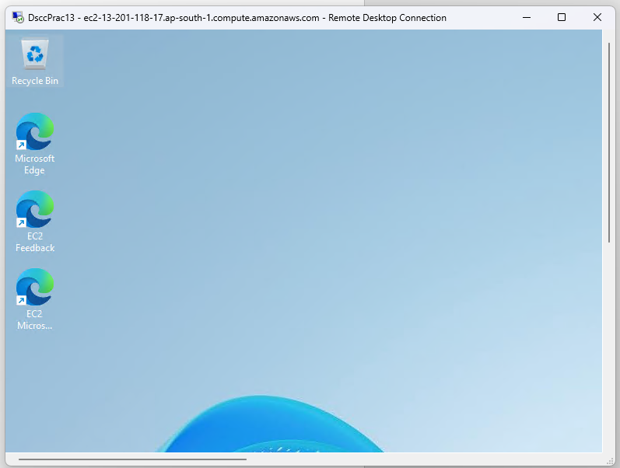

# 14. Install Virtual Box/VMware/ Equivalent open-source cloud Workstation with different flavours of Linux or Windows OS on top of Windows 8 and above.

Download VMWare Workstation and complete the installation.

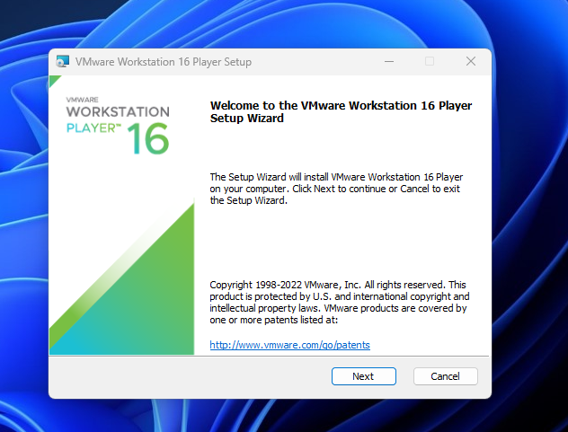

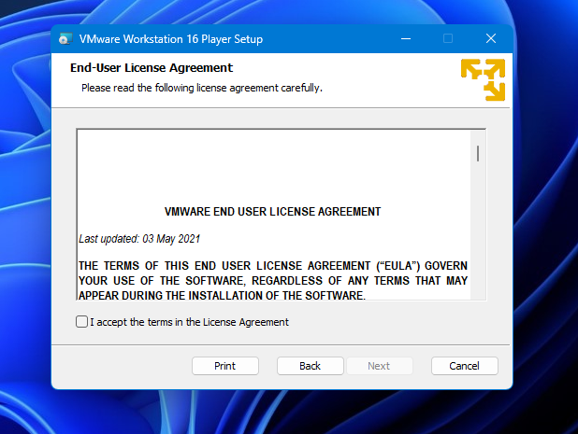

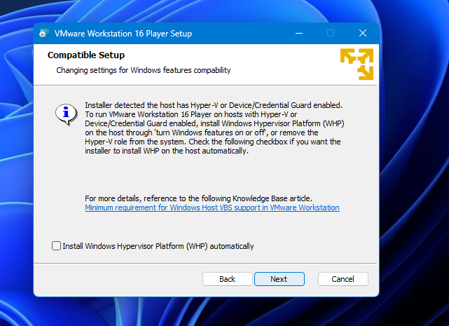

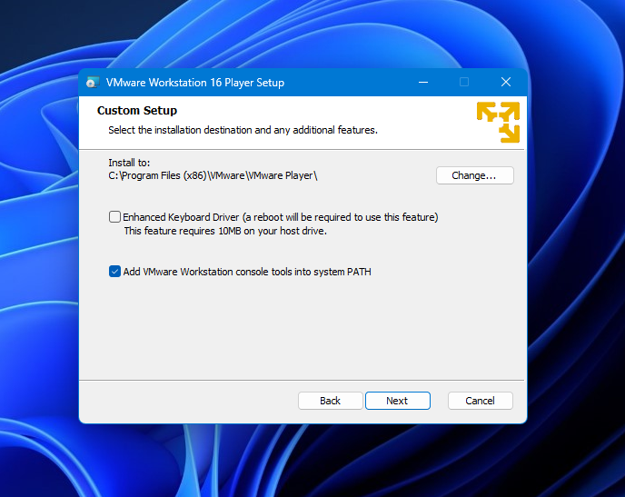

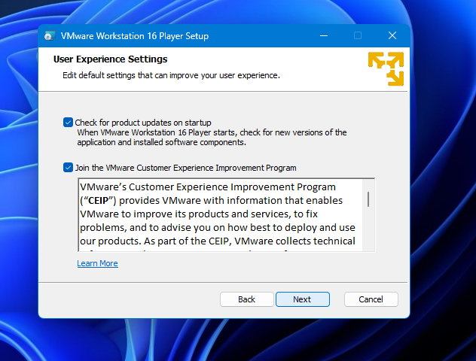

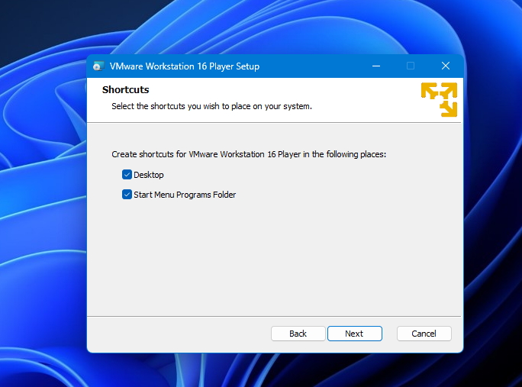

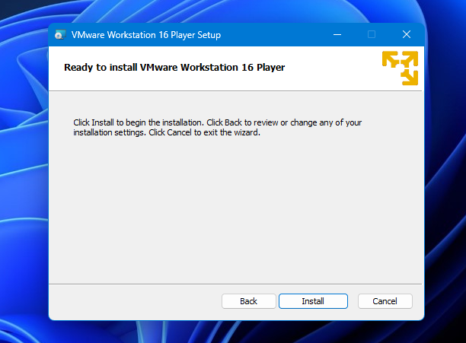

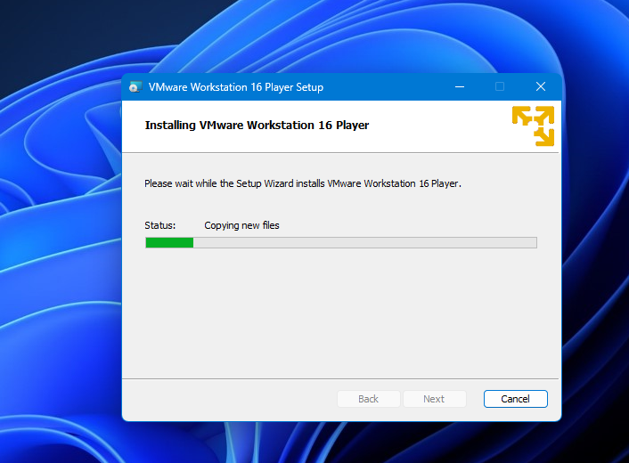

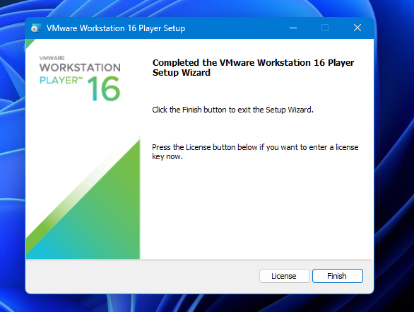

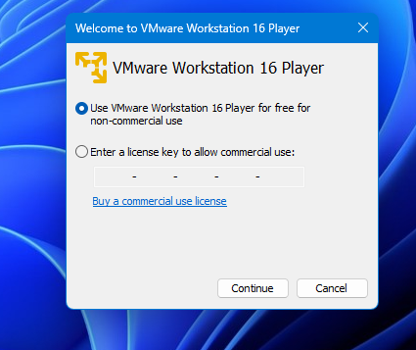

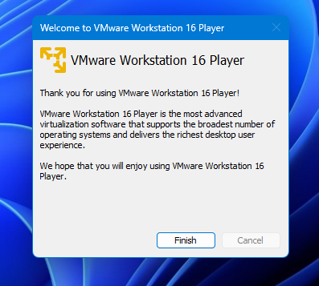

Create a New virtual Machine in VMWare.

